Sql day1

## Overview

SQL Server is a relational database management system (RDBMS) developed and marketed by Microsoft. As a database server, the primary function of the SQL Server is to store and retrieve data used by other applications.

### Intended Learning Outcomes

By the end of the program students should have full understanding of SQL queries, including DML and DDL statements, Transaction, Stored Procedure and Index.

* Master in basic sql queries including SELECT, WHERE, ORDER BY, GROUP BY, Aggregation Functions, JOIN and Subqueries.
* Familiar with advanced sql queries such as recursive CTE, Window Function, and UNION.
* Able to design database in SQL Server with Normalization and Index.
* Apply Stored Procedure to conduct DELETE/UPDATE/INSERT operations on tables.
* Apply User Defined Functions to create calculations.
* Familiar with Transactions along with concurrency problems and isolation level.
* Have basic knowledge of query performance tuning using Execution Plan and SQL Profiler

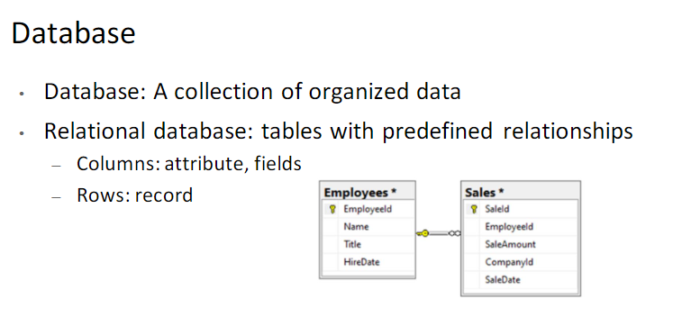

How to manage a relational database?

•SQL stands for Structured query language

•RDBMS: Relational Database Management System

-We use SQL Server

SQL Server Services

❑SQL Server: relational database server

❑SQL Server Agent: automation

❑SQL Server Browser: manage multiple instances

❑SQL Server Integration Services: ETL

❑SQL Server Analysis Services: OLAP

❑SQL Server Reporting Services: create reports to better understand your data

❑Notification Services: send notifications when data has changed

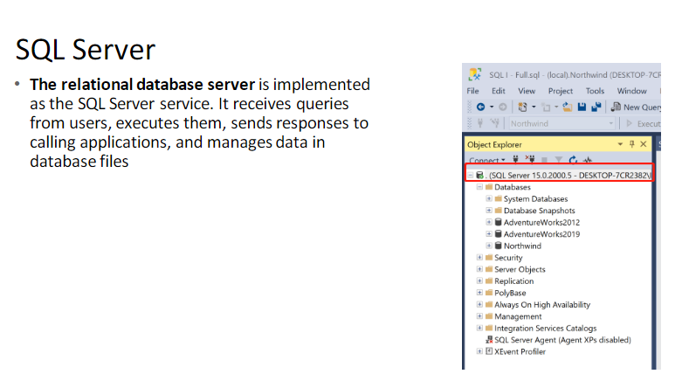

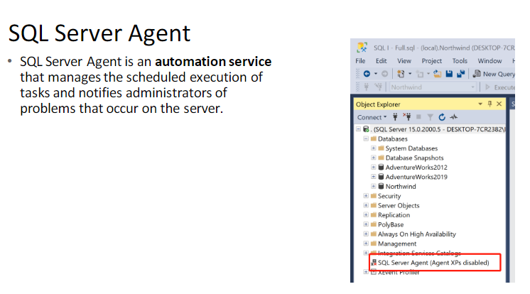

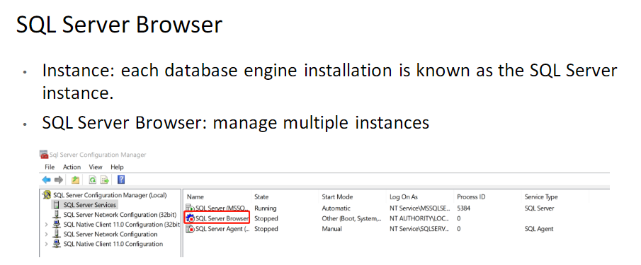

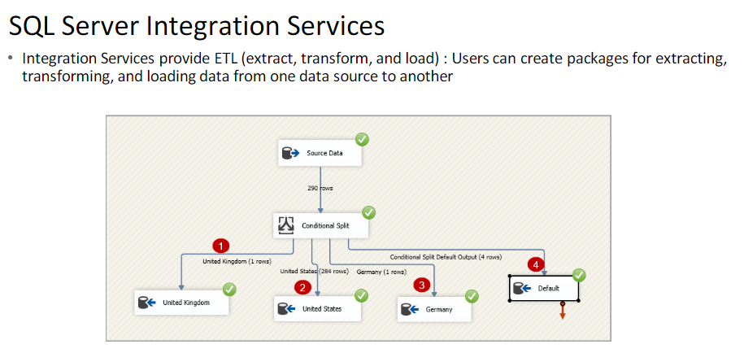

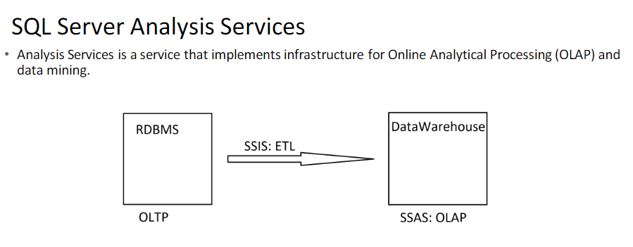

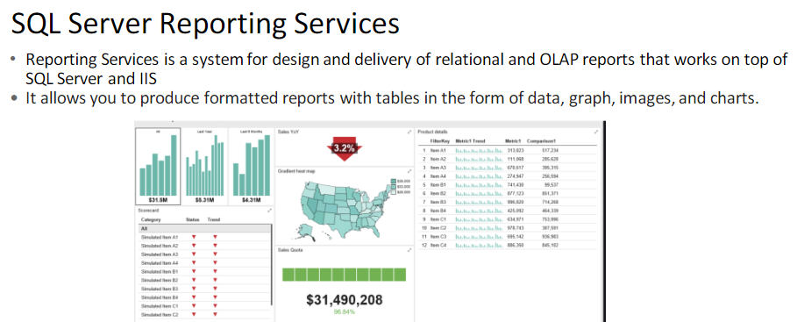

Notification Services

•Notification Services:

The notifications allow applications to be notified when data has changed, so once there is a source data change, the related user will be notified by email or short messages.

SQL Server Tools

❑SQL Server Configuration Manager

❑SQL Server Books Online (BOL)

❑SQL Server Management Studio

❑SQL Server Profiler

❑Database Engine Tuning Advisor

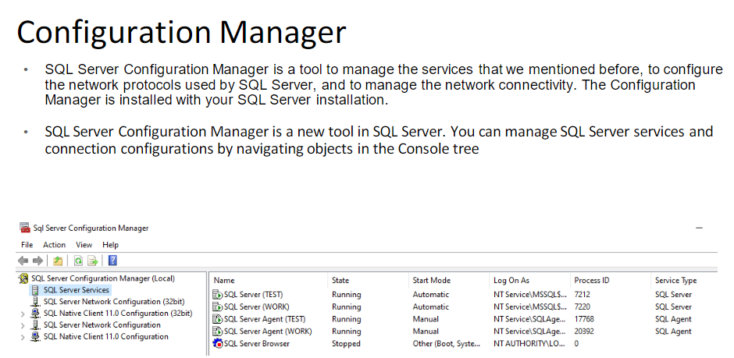

SQL Server Books Online

•SQL Server Books Online covers the concepts and procedures required to use SQL Server effectively. It’s like a huge help file provided by Microsoft, and you can install it on your local server, and use it in your SQL Server Management Studio, or you can simply use the online version. (search for sql server documentation) Here is the link:

https://docs.microsoft.com/en-us/sql/sql-server/?view=sql-server-ver15•

It is exactly the same as the downloaded version.

Management Studio

•Microsoft SQL Server Management Studio, new in Microsoft SQL Server, is an integrated environment for

accessing, configuring, managing, administering, and developing all components of SQL Server.

•SQL Server Management Studio combines the features of Enterprise Manager, Query Analyzer, and Analysis

Manager, included in previous releases of SQL Server, into a single environment. In addition, SQL Server

Management Studio works with all components of SQL Server such as Reporting Services, Integration

Services, SQL Server Compact Edition, and Notification Services. Developers get a familiar experience, and

database administrators get a single comprehensive utility that combines easy-to-use graphical tools with rich scripting capabilities

SQL Server Profiler

•SQL Server Profiler: an interface to create and manage traces and analyze and replay trace results

Types Of Statements

•Data Definition Language (DDL) statements, which allow you to create objects in the database

CREATE object_name

ALTER object_name

DROP object_name

•Data Control Language (DCL) statements, which allow you to determine who can see or modify the data.

GRANT

DENY

REVOKE

•Data Manipulation Language (DML) statements, which allow you to query and modify the data

SELECT

INSERT

UPDATE

DELETE

Copyri ght © 2015 Antra , I nc. All ri ghts re served.

Introduction

•Microsoft SQL Server database is a collection of objects that hold and manipulate data

•properties and features

It is a collection of many objects, such as tables, views, stored procedures, and constraints.

It is owned by a single SQL Server login account .

It maintains its own set of user accounts, roles, schemas, and security .

It has its own set of system tables and views to hold the database catalog .

It has its own transaction log and manages its own transactions.

It can range in size from 1 megabyte (MB) to a technical limit of 1,048,516 terabytes .

It can grow and shrink, either automatically or by command.

It can have objects joined in queries with objects from other databases in the same SQL Server instance or on linked servers.

SQL Server Instance

•An SQL Server instance, or Database Engine Instance, is a complete SQL server and you can install many instances on a machine but you can have only 1 default instance. An SQL Server instance has its own copy of the server files, databases and security credentials. ... Each instance manages several system databases and one or more user databases.

•An instance of the Database Engine is a copy of the sqlservr.exe executable that runs as an operating system service. Each instance manages several system databases and one or more user databases. Each computer can run multiple instances of the Database Engine. Applications connect to the instance in order to perform work in a database managed by the instance.

System Databases

•A new SQL Server installation always includes four databases

❑master

❑model

❑tempdb

❑mssql system resource (hidden)

❑msdb

Master

•The master database is composed of system tables that keep track of the server installation as a whole

and all other databases that are subsequently created. Although every database has a set of system

catalogs that maintain information about objects it contains, the master database has system catalogs that

keep information about disk space, file allocations and usage, systemwide configuration settings,

endpoints, login accounts, databases on the current instance, and the existence of other SQL servers (for

distributed operations).

•The master database is critical to your system, so always keep a current backup copy of it. Operations such

as creating another database, changing configuration values, and modifying login accounts all make

modifications to master, so after performing such actions, you should back up master

Model

•The model database is simply a template database. Every time you create a new database, SQL Server makes a copy of model to form the basis of the new database. If you’d like every new database to start out with certain objects or permissions, you can put them in model, and all new databases will inherit them. You can also change most properties of the model database by using the ALTER DATABASE command, and those property values will then be used by any new database you create.

Tempdb

•The tempdb database is used as a workspace. It is unique among SQL Server databases because it’s re-created–not recovered–every time SQL Server is restarted. It’s used for temporary tables explicitly created by users, for worktables that will hold intermediate results created internally by SQL Server during query processing and sorting, for maintaining row versions used in

•The tempdb database sizing and configuration is critical for optimal functioning and performance of SQL

Server

Mssql system resource

•The mssql system resource database is a hidden database and is usually referred to as the resource database. Executable system objects, such as system stored procedures and functions, are stored here.

Msdb

•The msdb database is used by the SQL Server Agent service, which performs scheduled activities such as backups and replication tasks, and the Service Broker, which provides queuing and reliable messaging for SQL Server.

•When you are not performing backups and maintenance on this database, you should generally ignore msdb.

•All the information in msdb is accessible from Object Explorer in SQL Server Management Studio, so you usually don’t need to access the tables in this database directly. You can think of the msdb tables as another

form of system tables

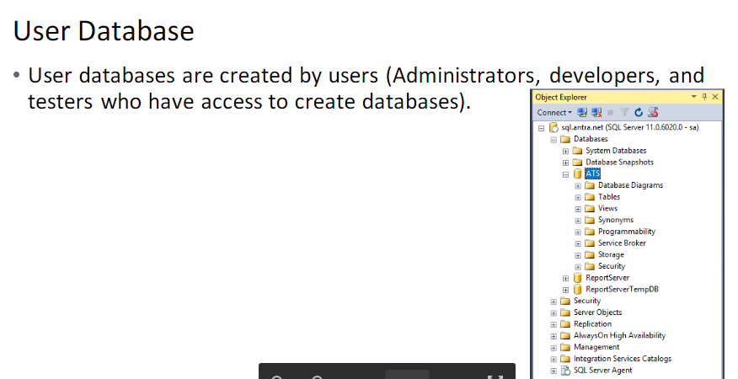

Copyri ght © 2015 Antra , I nc. All ri ghts re served.

Database Files

•

A database file is nothing more than an operating system file. (In addition to database files)

Primary data files: Every database has one primary data file that keeps track of all the rest of the files in the database, in addition to storing data. By convention, a primary data file has the extension .mdf.

Secondary data files: A database can have zero or more secondary data files. By convention, a secondary data file has the extension .ndf.

Log files: Every database has at least one log file that contains the information necessary to recover all transactions in a database. By convention, a log file has the extension .ldf.

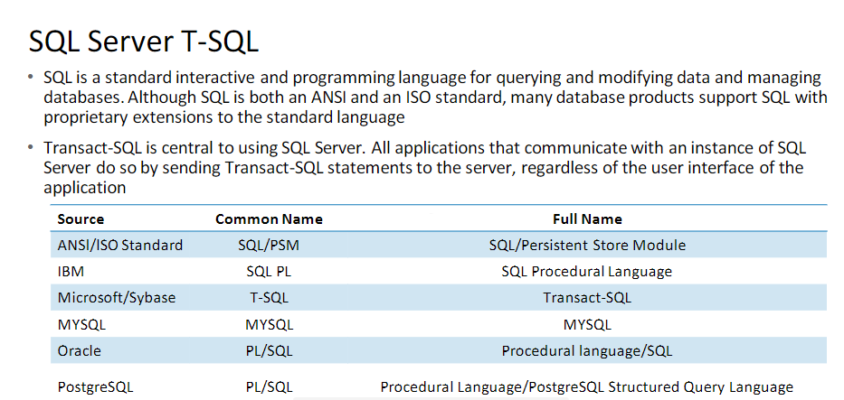

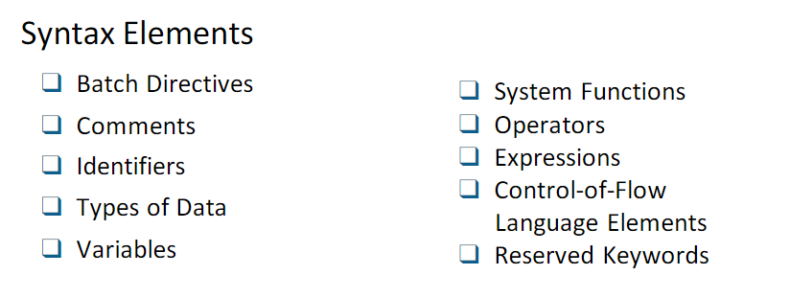

Retrieving Data

❑Retrieving Data by Using the SELECT Statement

❑Filtering Data

❑Formatting Result Sets

❑How Queries Are Processed

❑Performance Considerations

Result Set

•Result set is a set of data, could be empty or not, returned by a select statement, or a stored procedure, that is saved in RAM or displayed on the screen.

•A TSQL script can have 0 to multiple result sets.

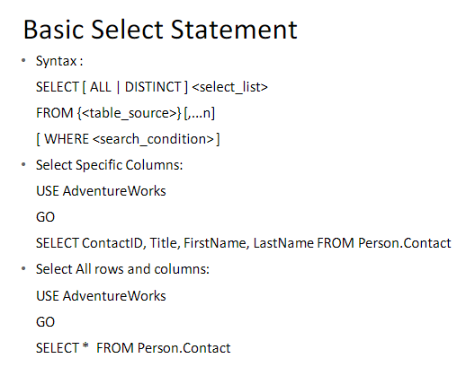

Select Statement

•Select statements with specified column name is always preferred than using select *, for performance reasons and accuracy issues.

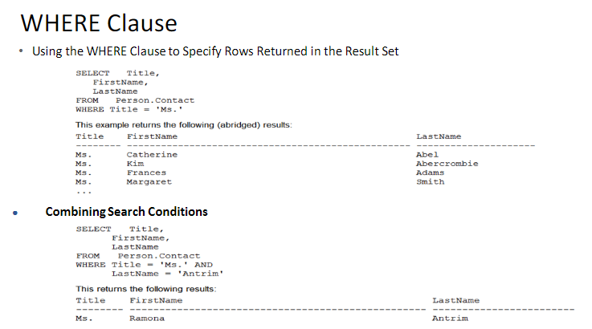

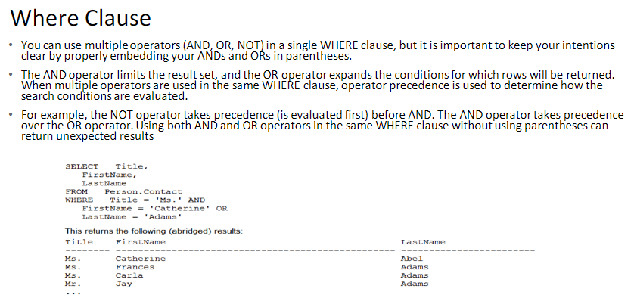

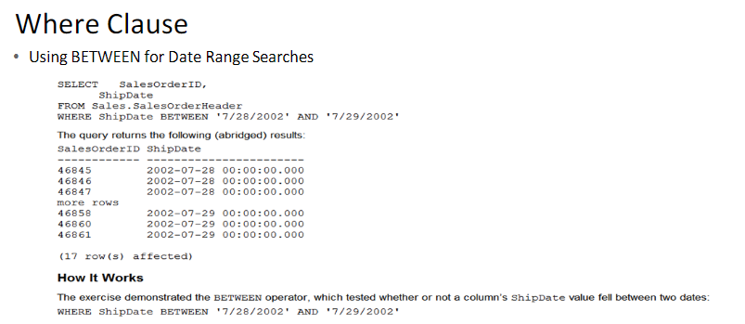

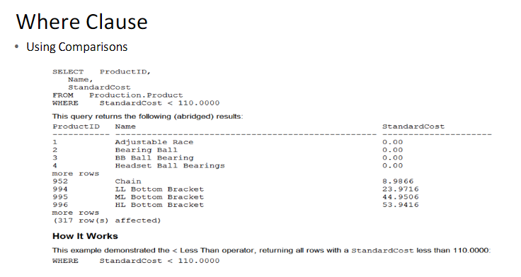

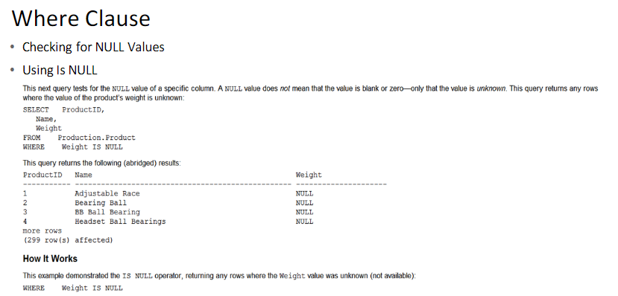

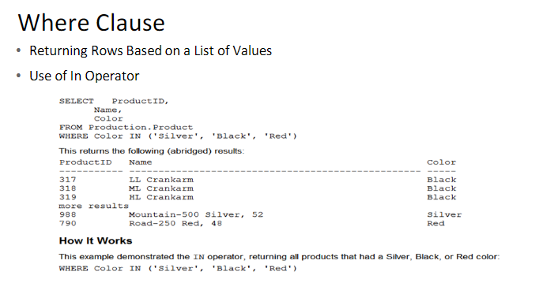

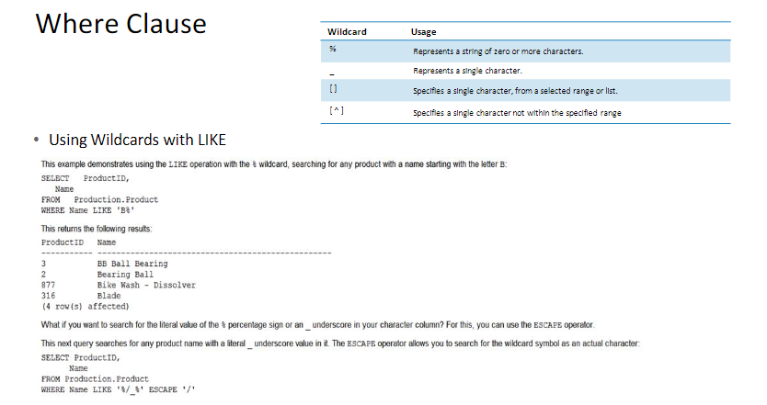

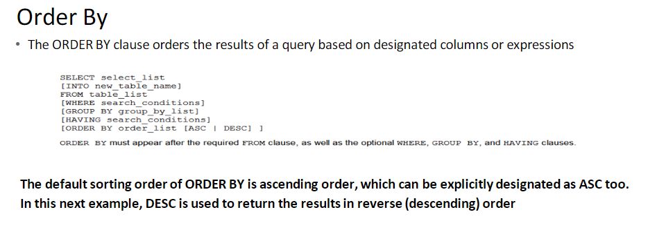

Joins

•Querying from More Than One Data Source

•The JOIN keyword allows you to combine data from multiple tables and/or views into a single result set. It joins a column or columns from one table to another table, evaluating whether there is a match.

•With the JOIN keyword, you join two tables based on a join condition. Most often you’ll see a join condition testing the equality of one column in one table compared to another column in the second table.

•joined columns do not need to have the same name, only compatible data types.

•SQL Server join types fall into three categories:

inner, outer, and cross. Self join is not a category. Left,

Right and Full are outer joins.

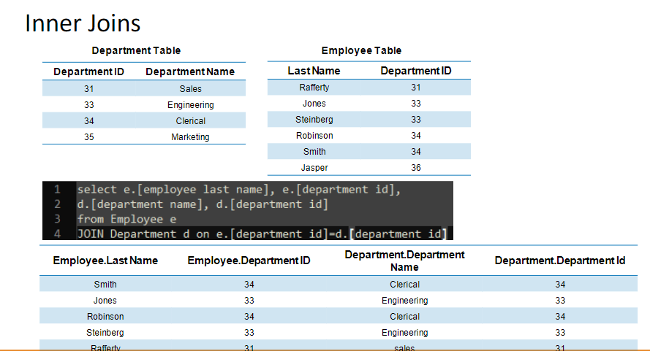

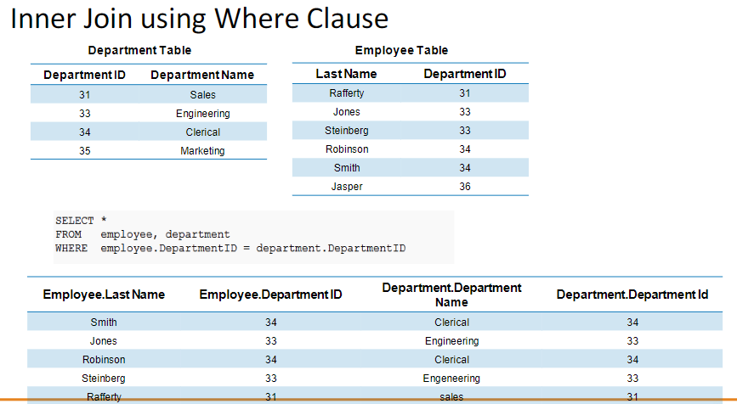

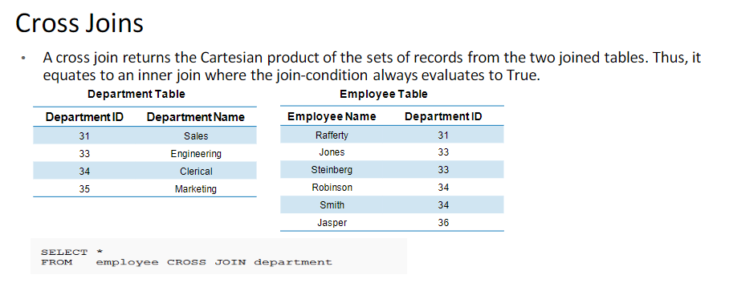

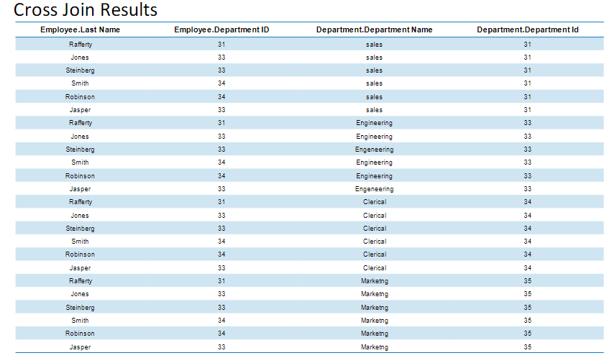

Outer Joins

•Outer joins have three different join types:

•LEFT OUTER, RIGHT OUTER, and FULL OUTER joins. LEFT OUTER and RIGHT OUTER JOINs

•LEFT JOIN or LEFT OUTER JOIN

The result set of a left outer join includes all the rows from the left table specified in the LEFT OUTER clause, not just the ones in which the joined columns match. When a row in the left table has no matching rows in the right table, the associated result set row contains null values for all select list columns coming

from the right table.

•RIGHT JOIN or RIGHT OUTER JOIN

A right outer join is the reverse of a left outer join. All rows from the right table are returned. Null values are returned for the left table any time a right table row has no matching row in the left table.

•FULL JOIN or FULL OUTER JOIN A full outer join returns all rows in both the left and right tables. Any time a row has no match in the other table, the select list columns from the other table contain null values. When there is a match between the tables, the entire result set row contains data values from the base tables.

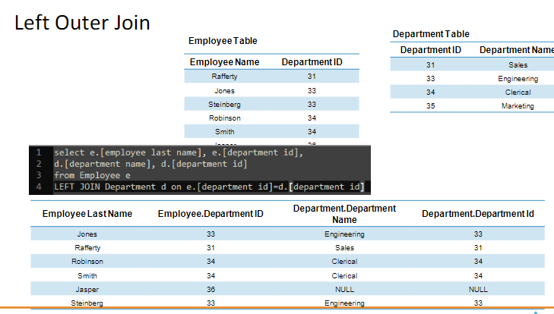

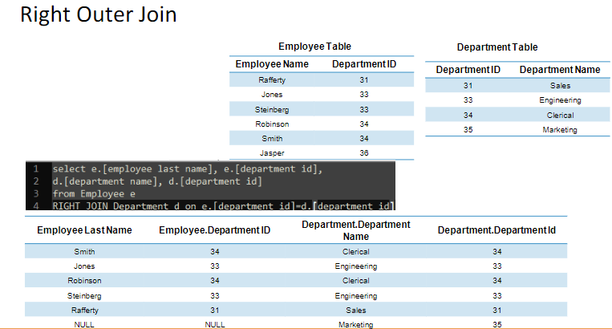 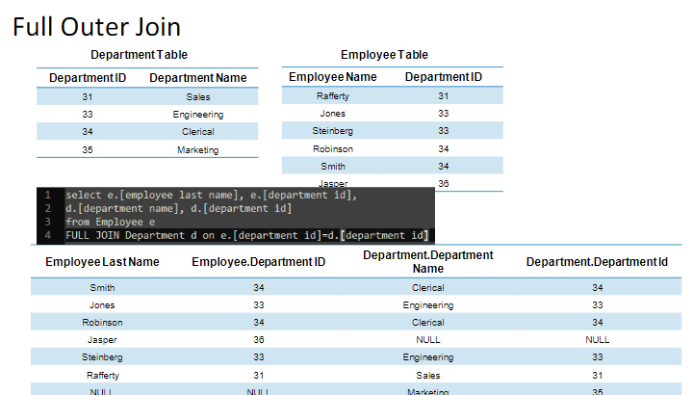 Outer Join Tips

•To select records in table A that does not have a match in table B, you can use table A left join table B, then in the where condition saying B.(primary key) is null

Batch Directives

•SQL Server processes single or multiple Transact

-SQL statements in batches. A batch directive instructs SQL Server to parse and execute all of the instructions within the batch. There are two basic methods for handing off batches to SQL Server.

–GO: SQL Server utilities interpret GO as a signal to send the current batch of Transact

-SQL statements to SQL Server. A GO command delineates batches of Transact

-SQL statements to tools and utilities and ends the batch. A GO command is not an actual Transact

-SQL statement.

–EXEC :The EXEC directive is used to execute a user

-defined function, system procedure, user

-defined stored procedure, or an extended stored procedure; it can also control the execution of a character string within a Transact

-SQL batch. Parameters can be passed as arguments, and a return status can be assigned.

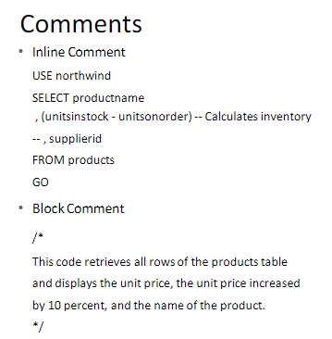 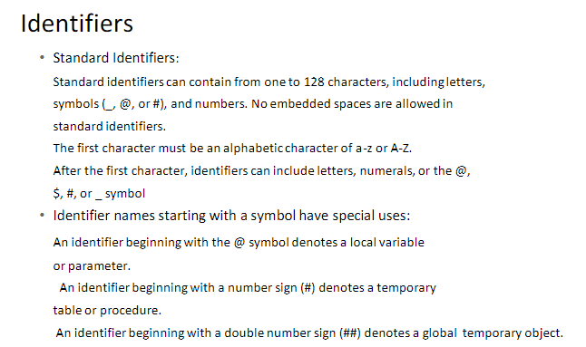

Identifiers

•Delimited Identifiers

If an identifier complies with all of the rules for the format of identifiers, it can be used with or without delimiters. If an identifier does not comply with one or more of the rules for the format of identifiers, it must always be delimited

•Delimited identifiers can be used in the following situations:

When names contain embedded spaces.

When reserved words are used for object names or portions of object names

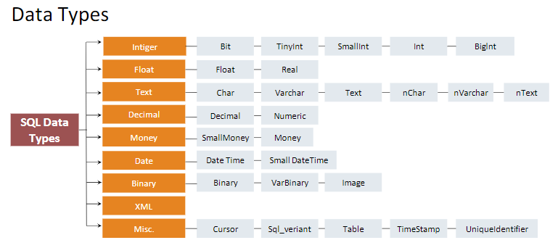

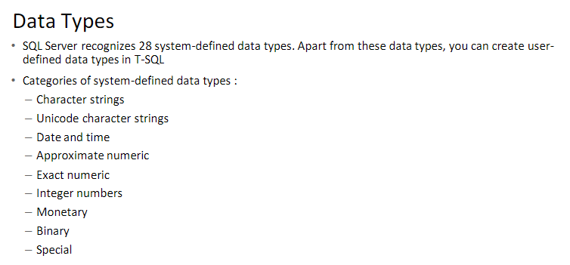

Character Strings

•

Char /nchar

The char data type is used to store strings of fixed size. The maximum size of this data type is 8,000 characters, which is a

si

gnificant

increase over the 255

-

character limit in early versions. When a variable or a table column is assigned with a string that is sho

rter than

its nominal size, it is padded with trailing spaces to fill the specified field length

•

Varchar / nvarchar

The varchar data type stores strings of variable size up to 8,000 characters long. When a character value whose length is less than the nominal size is assigned to the column or variable, SQL Server does not add trailing spaces to it, but records it as is. varchar data types occupy two additional bytes in order to record the length of the string

•varchar(max)

Varchar (max) looks and operates like the varchar data type, but it is by internal structure and functionality actually much more like the text data type.

•Text

The text data type is used to store huge amounts of data. One field can store up to 2GB (231

-1 bytes) of information. Only a 16-byte pointer to this data is stored in the table. Therefore, additional processing overhead is involved with the use of text columns.

There are special functions for processing text values. You cannot use union on Text.

Unicode Character Strings

•nchar

•nvarchar

•nvarchar(max)

•Ntext

Similar to character strings but accepts Unicode characters

Example:

Create table Contacts (ContactId char(8), Name varchar(50), Note text, Resume varchar(max))

Create table Contacts_2(ContactId nchar(8), Name nvarchar(50), Note ntext, Resume nvarchar(max)) go

Date Time

•Date time

•Small date time

. Date

•Datetime2

The main difference between these two data types is in the amount of space they occupy, date time occupies 8 bytes and small date time only 4 bytes. Other differences between the two types are the precision of the date stored and the range of dates that can be used. The precision of small date time is one minute, and it covers dates from January 1, 1900, through June 6, 2079, which is usually more than enough.

The precision of date time is 3.33 ms, and it covers dates from January 1, 1753, to December 31, 9999.

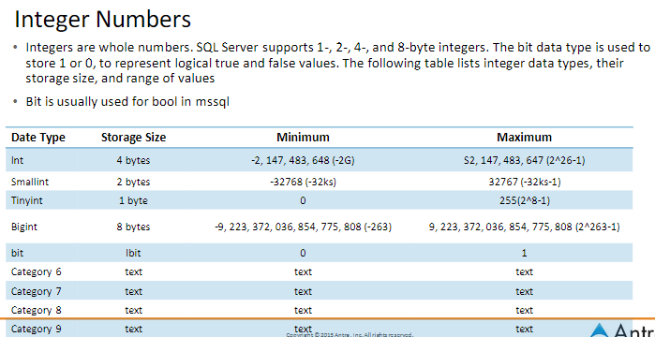

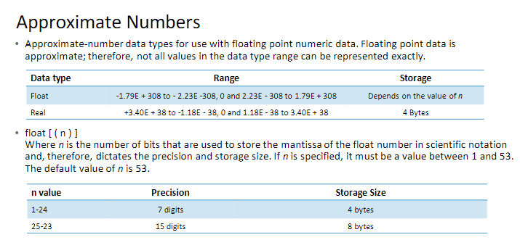

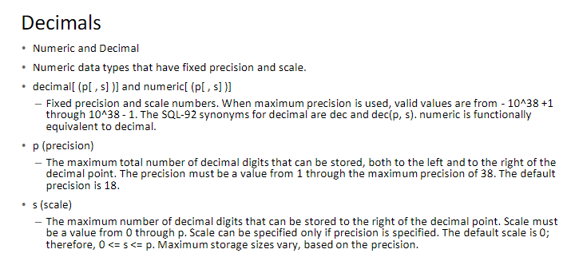

Monetary Data Types

•The money and small money data types are a compromise between the precision of decimal numbers and the small size of real numbers, small money occupies 4 bytes and uses the same internal structure as int numbers.

•The data can have up to four digits after the decimal point. For this reason, you can store numbers ranging from −214,768.3648 to 214,768.3647 in the small money data type.

•The money data type uses the same structure for storing information as the bigint data type. It occupies 8 bytes for storage, so its values must range from −922,337,203,685,477.5808 to +922,337,203,685,477.5807.

•Monetary constants can be preceded by $ or one of 18 other currency symbols (listed in SQL Server Books Online):

•update Inventory

Set Rent = $0, LeaseCost = $119.95

Where InventoryId = 3432

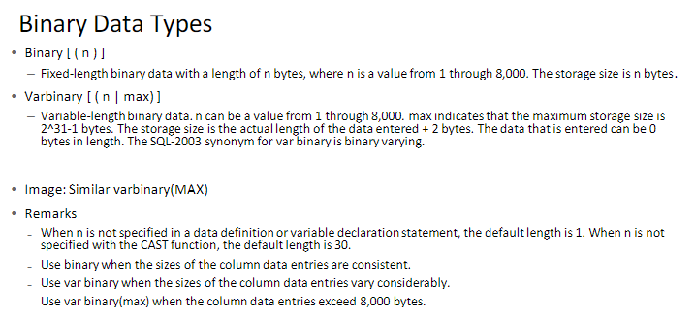

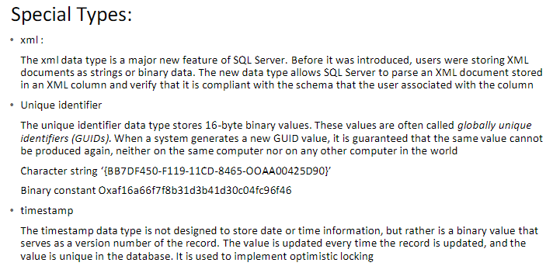 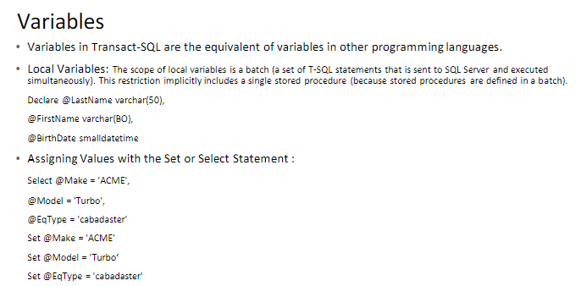 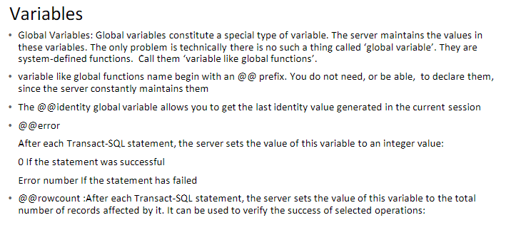

Flow

-control Statements

❑Statement block

❑If... Else

❑While...Break

❑Break

❑Continue GoTo

❑WaitFor

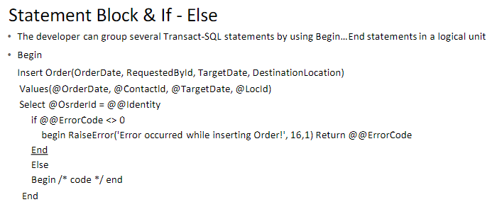

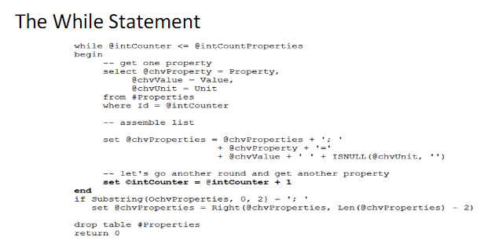 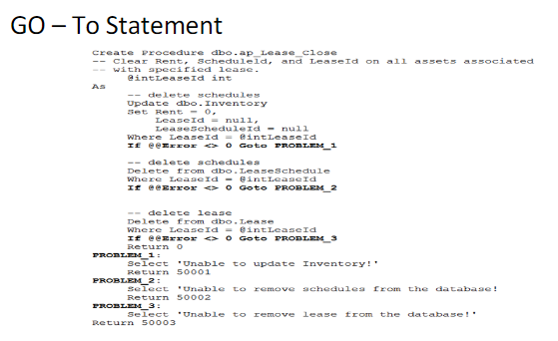 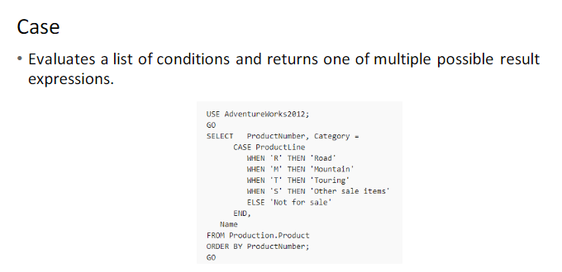

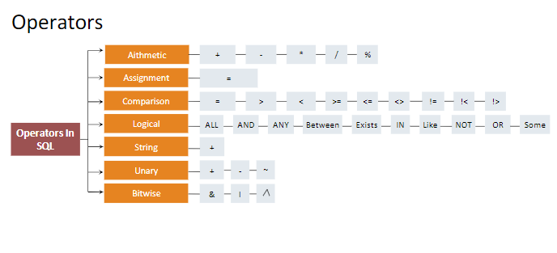

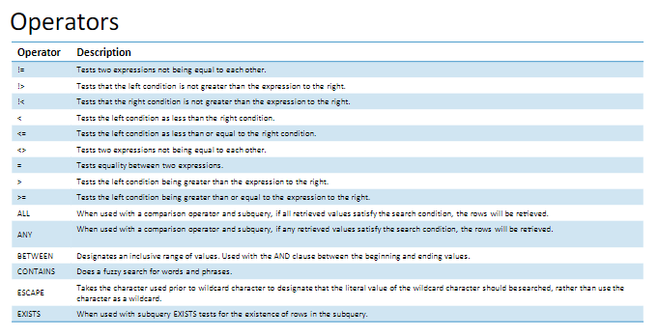 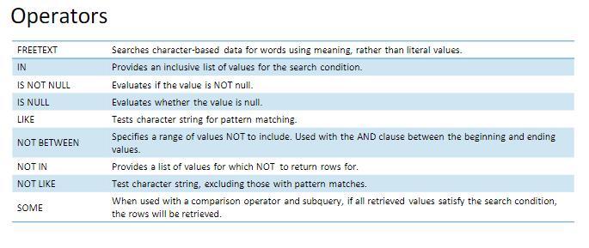

#### **Database Introduction**

Structured set of data held in a computer, especially one that is accessible in various of ways.

To interact and manage a Databases, we need a…

Database Management System:

Allows us to CRUD and manipulate a database. Different types include NDBMS, HDBMS, OODBMS, but the one that is far most popular today and what we will use is RDBMS

RDBMS and Non-Relational Databases:

Relational: A relational database is a database that forms relations between tables that store data with specific element using SQL (Structured Query Language).

Non-Relational: Flexible data from no schema limitations. It uses columns and rows to enter type of data and values with Key-Value pairs. Can be seen in file types like JSON, XML... etc.

Services

SQL Server Services: Allows you to use SQL server to store your data.

OLTP: ONLINE TRANSACTION PROCESSES1: The files that “Amazon” uses to keep “reviews” up to a limit. The file you interact with on a day to day. Needs back-up occasionally depending on the company. The backup is stored in the data center.

OLAP: ONLINE ANALYTICAL PROCESSES1: the data center itself.

SQL Server Agent: Allows the creation of “Jobs” that help automate processes

SQL Server Analytical Services: uses OLAP data for analysis.

SQL Server Browser Services: Manage multiple instances

SQL Server Reporting Services: Creates reports like Cash flow and transaction reports.

SQL Notification Services: Mails, SMS, or notifications to alert changes

Distributed Transaction Coordinator: helps manage transactions from other places. Two phase services.

SQL Server Integration Services: ETL (Extract Transform Load) from the OLTP. It is sometimes normalized; we might need to deformalize it to upload it into OLAP.  
Essentially a DTS Data transfer service.

SQL Server Configuration Manager: Allows multiple people to connect to a URL or an IP address where the database is (Browser Service). The SQL Server will run on port 1433 on default.  
Checks protocols and configuration.

SQL Server System Databases

Master: catalog database, keeps info on all user defined databases (.mdf master data file is different from the extension)

Model: whenever you make a database, right click -> properties. You can now change the size. Files -> size(mb), but if you change the model’s properties, the settings change for the next database accordingly. “Alter database” is the command

Msdb: where server agent keeps its activities

Tempdb: keeps temporary tables for usage in the query. Removes all tables after closing SQL

Mssql system resource: Predefined functionalities. Predefined stored procedures are held here. Exampled of a stored procedure stored is Sp_Help which gives you a table of object name, owner, and object type of everything in the database.

Database Files

A database file is nothing more than an operating system file. (In addition to database files)

Primary data files: Every database has one primary data file that keeps track of all the rest of the files in the database, in addition to storing data. By convention, a primary data file has the extension .mdf

Secondary data files: A database can have zero or more secondary data files. By convention, a secondary data file has the extension .ndf. Database partitioning is used to reduce burden of size in one file. Right click, properties, files, file group. “Secondary” leave it as it is.

Log files: Every database has at least one log file that contains the information necessary to recover all transactions in a database. By convention, a log file has the extension .ldf.

1https://www.ibm.com/cloud/blog/olap-vs-oltp

SQL Basics

SQL stands for Structured Query Language. They allow us to use query commands in order to manipulate data or showcase a result set using keywords1.

Result set: a set of data, could be empty or not, returned by a select statement, or a stored procedure, that is saved in RAM or displayed on the screen

Types of Statements

Data definition language (DDL): Allows creation objects in database with:

Create, Alter, Drop

Data Control Language (DCL): allows you to determine who can see or modify the data.

            GRANT, DENY, REVOKE

Data Manipulation Language (DML): Allows query and modify the data:

            Select, Insert, Update, Delete.

Basic Query Keywords:

Select: Displays only the following chosen columns into the result set

From: Specify the table where the data is being selected

Where: Can add filters to the variables selected. You can add more conditions with the Keywords “AND”, “Or”, and “IN” IN being used to shorten “OR” statements in situations.

Group By: one or more columns as a group such that all rows within any group have the same values for those columns.

Having: Can add filters to aggregate selected data

Aliases: Use these to change the column name and for clarity in referencing in a more complex Select statement

-          Employee e

-          Employee “e”

-          Employee [e]

-          Employee ‘e’ (NOT RECOMMENEDED)

-          “As” can be inserted in between Employee and “e”

-          e = Employee, “e” = Employee, [e] = Employee

Wildcards: We use wildcards use to try to Select information when we only know part of the complete information. If little Timmy only knows his last name initial, we can use wildcards to narrow our search a lot with WHERE FirstName = ‘Timmy’ AND LastName LIKE ‘T%’2

Important Keywords: “LIKE”

We use “LIKE” because we are looking for a resemblance, not an exact match.

%: zero to any number of characters

_: a singular character

[]: brackets in this context can assist in including or excluding characters

^: used to exclude characters in brackets like the “NOT” keyword

-: used to suggest a range of characters

Identifiers and Delimiters: Best Explained in the ppt. However, do avoid usage of underscore as part of naming standards.

Datatypes: Pic from ppt! Ask me for more understanding with certain topics. Not going to lie but I haven’t used a ton of these. Varchar are strings and Bits can be used later to convert from and to Boolean.

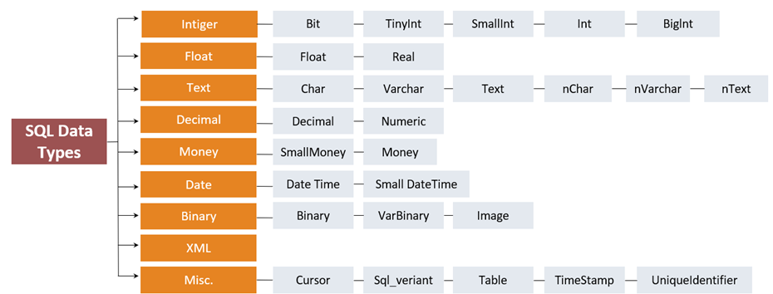

1 https://www.w3schools.com/sql/sql_ref_keywords.asp

2https://www.w3schools.com/sql/sql_wildcards.asp

#### Reading Material

* [SQL Queries](https://docs.microsoft.com/en-us/sql/t-sql/queries/queries?view=sql-server-ver15)
* [System Databases](https://docs.microsoft.com/en-us/sql/relational-databases/databases/system-databases?view=sql-server-ver15)
* [SQL Server Profiler](https://docs.microsoft.com/en-us/sql/tools/sql-server-profiler/sql-server-profiler?view=sql-server-ver15)
* [Data Types](https://docs.microsoft.com/en-us/sql/t-sql/data-types/data-types-transact-sql?view=sql-server-ver15)

#### FAQ

1. What does SQL Profiler do?
2. What's the life scope of local variable in SQL Server?
3. What are the databases in system databases folder and what's their functionalities?
4. Which statements are DDL statements, which are DML statements?

Sql day 2

MORE SQL

Joins: used to combine the result set of two or more than two tables

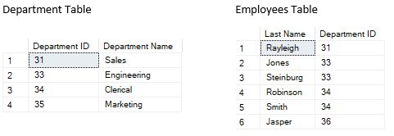

Inner join: used to fetch the data from both left and right table which satisfy the join condition.

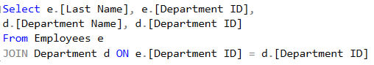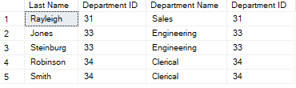

Cross Join: A cross join returns the Cartesian product of the sets of records from the two joined tables. Thus, it equates to an inner join where the join-condition always evaluates to True.

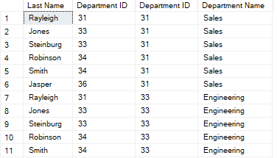

Left Join: used to fetch all the records from left table but only those records from right table which satisfy the join condition. for other records coming from left table right table will return null

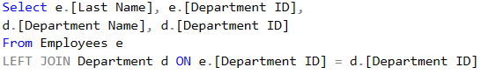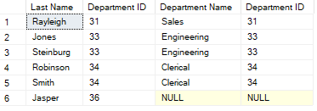

Right Join: is used to fetch all the records from right table but only those records from left table which satisfy the join condition. for extra records coming from right table left table will return null

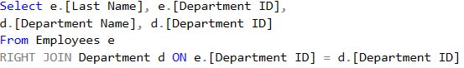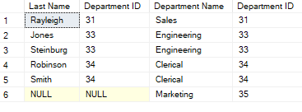

Full Join: it will fetch all the records from both left and right table and for extra records both tables will return null

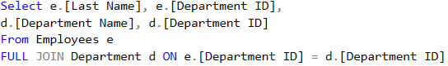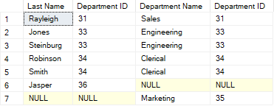

Self-Join: is used to when you are joining a table with itself. To write self-join we need to create two aliases of the same table

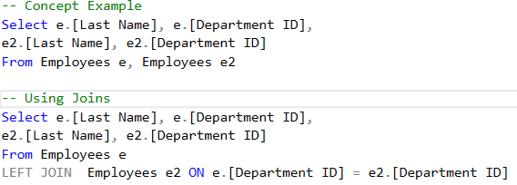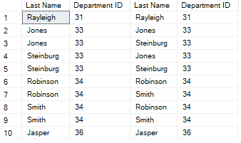

Aggregates

Aggregates: performs a calculation on a set of values and returns a single value.

### **A few common aggregates: AVG, COUNT, SUM, MIN, MAX**

Group By: used in a SELECT query to determine the groups that rows should be put in column that is not used in an aggregate function in the SELECT list must be listed in the GROUP BY clause.

Having: Selectively Querying Grouped Data Using HAVING

The HAVING clause of the SELECT statement allows you to specify a search condition on a query using GROUP BY and/or an aggregated value

The HAVING clause is used after the GROUP BY clause. The WHERE clause, in contrast, is used to qualify the rows that are returned before the data is aggregated or grouped. HAVING qualifies the aggregated data after the data has been grouped or aggregated.

Subqueries: A subquery is a SELECT query that is nested within another SELECT, INSERT, UPDATE, or DELETE statement. A subquery can also be nested inside another subquery

Use Cases:

when you need to use an already prefiltered table’s result set in another query

Increase performance using a prefiltered table

Can reduce clutter to increase readability

Correlated Subqueries:

In a SQL database query, a correlated subquery (also known as a synchronized subquery) is a subquery (a query nested inside another query) that uses values from the outer query. Because the subquery may be evaluated once for each row processed by the outer query, it can be inefficient.

Same reason to use Temporary Tables, CTEs and Table Variables if needed.

Derived Table: A subquery used in specifically the “From” clause

Unions: Concatenates the results of two queries into a single result set.

Union removes duplicate records (where all columns in the results are the same), Union All does not.

There is a performance hit when using Union vs Union All, since the database server must do additional work to remove the duplicate rows, but usually you do not want the duplicates especially in reports.

The condition of using Unions are that the number of columns and data type of each column from both result set should match in the order they are given.

Union & Union All are called set operators. There are two other types of SET Operators known as Intersect and Except. As the name suggests, they only return intersecting values and values that do not match respectively.

Common Table Expression (CTE): Specifies a temporary named result set

Improve readability and manageability of complex SQL Statements

-          Similar to VIEWs and even more to Derived Tables

-          Over time most of the CTEs will be used for this purpose

Recursive CTEs: Using CTEs and Unions, we can generate columns that can be used in the query following the CTE.

Views: A virtual table whose contents are defined by a query. Like a real table, a view consists of a set of named columns and rows of data. Views are updatable which also changes the table they are derived from. However, they are not updatable if the modification affects multiple base tables such as a view made from a join.

There are dangers of using views because they are updatable. In a scenario where Views are called in your program, there can be malicious attackers that use SQL Injection and do harm to your database. To prevent SQL Injection, we can use something called Stored Procedures.

Benefits:

-          Simplify Data Manipulation

-          Allows backward compatible interface

-          Customize Data: can use views to give relevant information with customization to the code based on login ID of user

Window Functions: Operate on a set of rows and return a single column. These allow you to do calculations like Count without grouping anything. This is achieved using the Keyword “Over”.

Partition By: Allows the window functions to be organized/grouped “In relation to” without having to collapse any rows.

Rank Functions: With window functions and the "Order By" Clause, there are built-in functions, to rank with the optional use of Partition By. This list is Rank(), Dense_Rank(), Row_Number(),  NTile().

The general syntax is Select field1, Aggregate(field2) Over([Partition By field3] Order By field4) From Table.

Sql day3

Temporary Table: Special type of table so that we can store data temporarily

Local Temporary Variable: As the name suggests, it is “local” scope meaning that it is only accessible in the session that it was created. Needs an identifier of “#”.

Global Temp Tables: any user with proper permissions access to the current database they are in have access to the table. Unlike local temporary tables, you can’t create simultaneous versions of a global temporary table, as this will generate a naming conflict. Needs an identifier of “##”.

There are different ways to create a temp table:

-        Define just like regular tables, only they are automatically stored in the tempdb database.

Create Table #LocalTemp(

column_name1 column_data_type1,

column_name2 column_data_type2…)

Insert (Into) #LocalTemp values (value1, value 2), (value3, value 4) OR

Insert (Into) #LocalTemp Select field1, field2, field3 from Table

--The (Into) is optional

-          Another way is using Select -> Into

Select * Into #CopyOfProducts From Products

The above method allows to skip the creation of the table process and only for Temp Tables.

Table Variable: a data type that can be used within a Transact-SQL batch, stored procedure, or function—and is created and defined similarly to a table, only with a strictly defined lifetime scope.

Reasons to use this:

•      Temporary tables causes performance issues

•      Temporary tables may cause unwanted disk overhead in tempdb, locking of tempdb during their creation, as well as cause stored procedure recompilations, when included within a stored procedure’s definition

•      Microsoft recommends table variables as a replacement of temporary tables when the data set is not very large. However, table variables performance suffers when the result set becomes too large

•      Well scoped. The lifetime of the table variable only lasts for the duration of the batch, function, or stored procedure

•      Shorter locking periods (because of the tighter scope).

•      Less recompilation when used in stored procedures

Use Syntax:

Declare @TableName Table (column_name1 column_data_type1)

Insert (Into) @TableName values (value1, value 2), (value3, value 4) OR

Insert (Into) @TableName Select field1, field2, field3 from Table

--Temp tables vs. table variables

--1. Storage: both Temp Tables and Table Variables are stored in tempDb

--2. Scope: Temp Tables scoped local/global; Table Variables scoped for current batch

--3. Temp Tables for large data; Table Variables for smaller data

--4. Usage: Temp Tables not in Stored Procedure, Functions; Table Variables can be used

--5. Structure: Temp Tables can create index/ constraints except Foreign key; Table Variables cannot

Sql day4

What is Index

One of the best ways to reduce disk I/O is to use an index

Allows SQL Server to find data in a table without scanning the entire table

Example

SELECT TOP 10 p.ProductID, p.[Name], p.StandardCost

, p.[Weight], ROW_NUMBER() OVER (ORDER BY p.Name

DESC) AS RowNumber FROM Production.Product p

ORDER BY p.Name DESC

Indexes

•Indexes are database objects based on table column for faster retrieval of data

•Query optimizer depends on indexed columns to function

•Separate structure attached to a table

•Contain pointers to the physical data

•Used to

–To quickly find data that satisfy conditions in the WHERE clause.

–To find matching rows in the JOIN clause.

–To maintain uniqueness of key column during INSERT and UPDATE.

–To Sort, Aggregate and Group data.

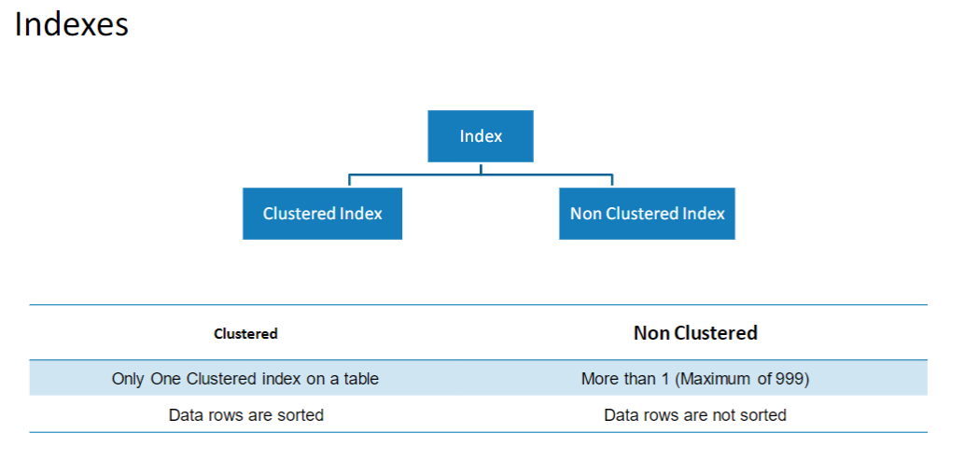

Types of Index

Clustered Index

–Primary Key Default (but not necessary)

–Data is stored at the leaf level

–Data is ordered by the key

Non-clustered Index

–Uses cluster key or RID of a heap

–INCLUDE stored at leaf

And the rest –outside the scope of this session

Index Tuning

•What an index is

•The benefits and overhead of an index

•General recommendations for index design

•Clustered and nonclustered index behavior and comparisons

•Recommendations or clustered and nonclustered indexes

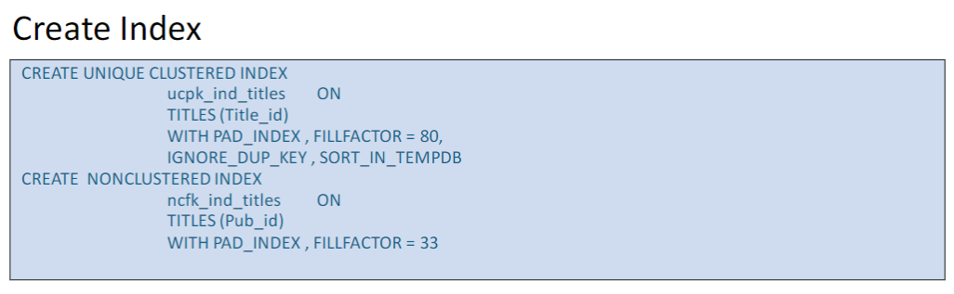

Disadvantages of Index

•Additional Disk Space

•Insert, Update, Delete Statement become slow

Index Rules

•Clustered Index

•Choose wisely. Only one per table possible

•Primary key by default is clustered. Evaluate default behavior

•Non-Clustered Index

•More than one possible.

•Foreign keys are always good candidate for non-clustered index

•(because of joins)

•Evaluate ‘Included Columns’ in Indexing. Every Non-Clustered

index contains Clustered Keys

•Choose Index Fill Factor wisely.

•Find out tables with large row counts but no indexing. Maybe it needs indexes.

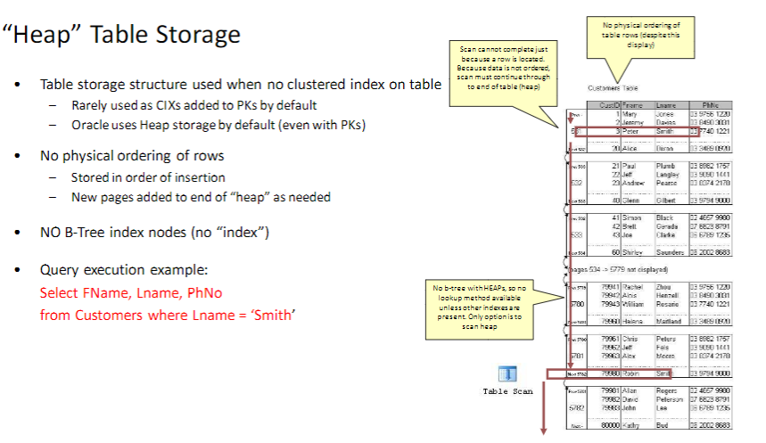 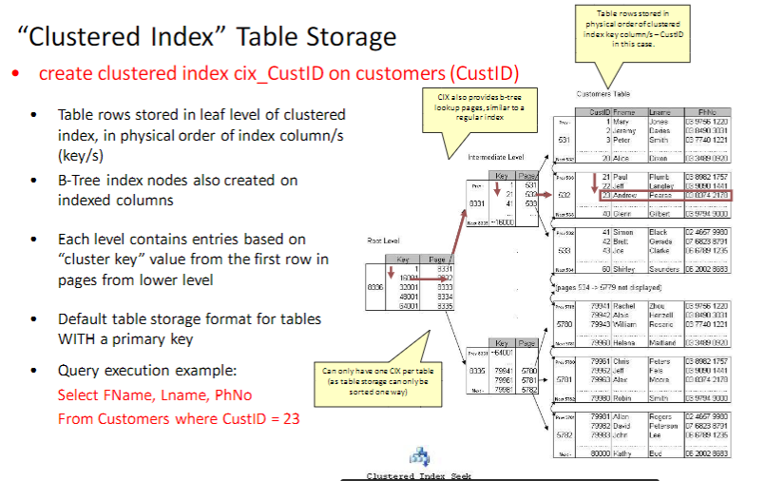 Index design recommendations

Examine the WHERE clause and JOIN criteria columns.

Use narrow indexes.

Examine column uniqueness.

Examine the column data type.

Consider column order.

Consider the type of index (clustered versus non-clustered).

Agenda

•SQL: set based expression / serial execution

•Intro to execution plans

•Table & index access methods

–Table storage formats

–Heaps & Clustered Indexes

–Non-clustered Indexes (on Heaps vs on Clustered Indexes)

–Covering Indexes

•Join operators

–Nested Loops Join, Merge Join & Hash Join

•Top 10 for Efficient Queries

•Efficient usage of Procedures and Views

Why Performance Tuning in SQL Server is necessary

•Allowing your system to scale

••Adding more customers

••Adding more features

•Improve overall system performance

•Save money but not wasting resources

•The database is typically one of the most expensive resources in a datacenter

Major Performance Killers

•Insufficient indexing

•Inaccurate statistics

•Improper query design

•Poorly generated execution plans

•Excessive blocking and deadlocks

•Non-set-based operations, usually T-SQL cursors

•Inappropriate database design

•Excessive fragmentation

•Non-reusable execution plans

•Frequent recompilation of queries

•Improper use of cursors

•Improper configuration of the database transaction log

•Excessive use or improper configuration of tempdb

Intro to execution plans

•Why is understanding Execution Plans important?

•Tune performance problems at the source (query efficiency)

–More effective than tuning hardware

–Other diagnostics only reveal consequences of poor query execution plans

•High CPU is only a consequence of poorly tuned query plans

•High disk utilization usually just a consequence of poorly tuned query plans

•Waitstats reveals high resource utilization of poorly tuned query plans

•Locking usually just a consequence of poorly tuned query plans

•Tuning query execution plans is a VERY important tuning technique

•Provides insight into query execution steps / processing efficiency

-SQL Server occasionally makes mistakes

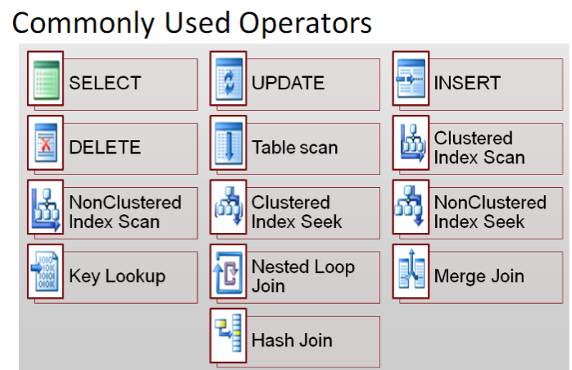 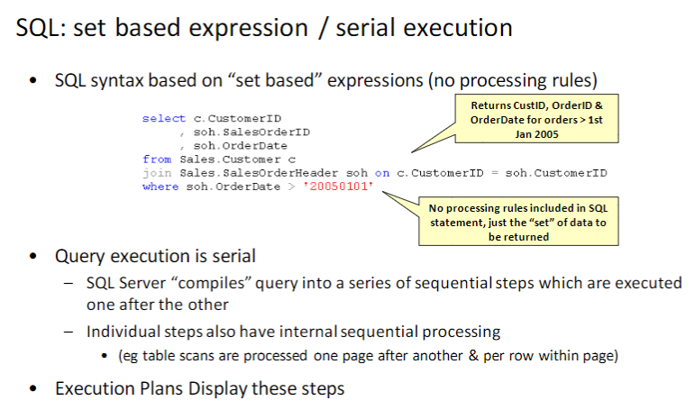 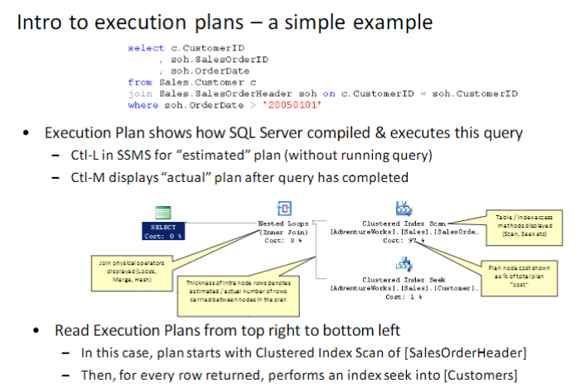

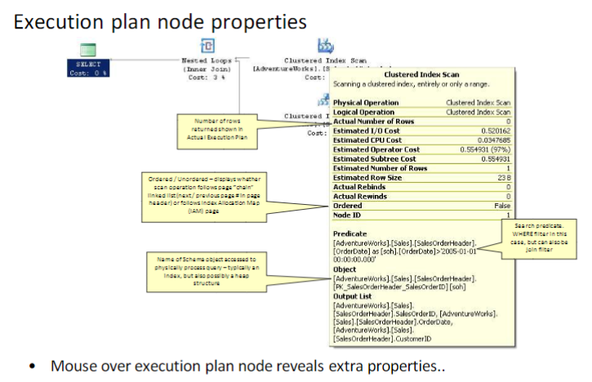

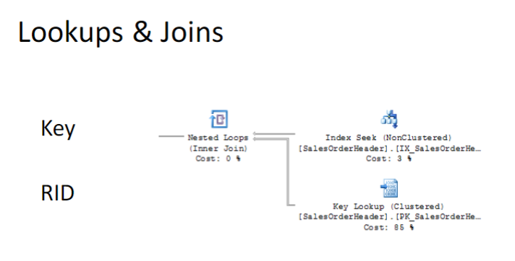

Join Optimization

Hash joins

Merge joins

Nested loop joins

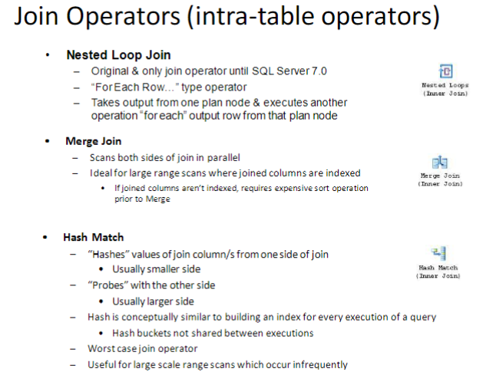

Hash Join

•A hash join uses the two join inputs as a build input and a probe input.

•The build input is shown as the top input in the execution plan, and the probe input is shown as the bottom input.

•Usually the smaller of the two inputs serves as the build input because it's going to be stored on the system, so the optimizer attempts to minimize the memory used.

•The hash join performs its operation in two phases: the build phase and the probe phase.

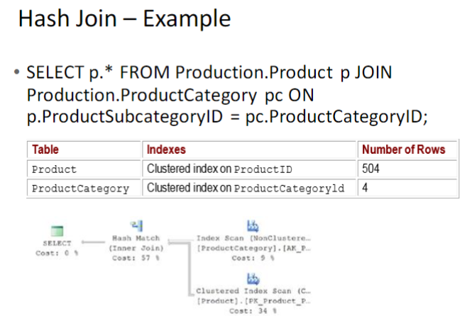

Merge Join

•A merge join requires both join inputs to be sorted on the merge columns, as defined by the join criterion

•Since each join input is sorted, the merge join gets a row from each input and compares them for equality

•A matching row is produced if they are equal. This process is repeated until all rows are processed

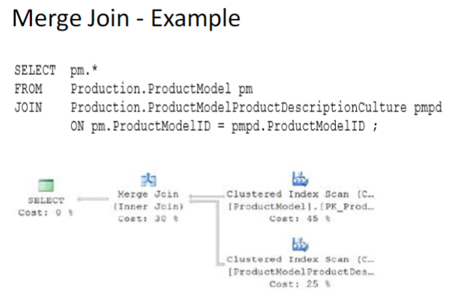

Nested Loop Join

•A nested loop join uses one join input as the outer input table and the other as the inner input table

•The outer input table is shown as the top input in the

execution plan, and the inner input table is shown as the bottom input table

•The inner loop, executed for each outer row, searches for matching rows in the inner input table

•Nested loop joins are highly effective if the outer input is quite small and the inner input is larger but indexed

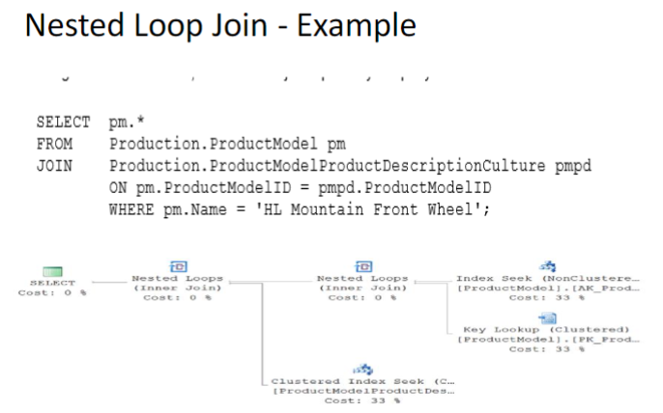

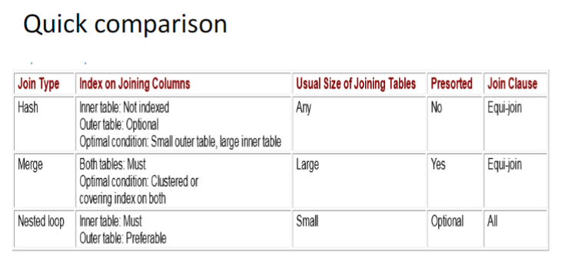

Force Changing of the Execution Plans

1, Use DBCC

2, run system sp of sp_query_store_force_plan

Top 10 for Building Efficient Queries

1 Favor set-based logic over procedural or cursor logic

• The most important factor to consider when tuning queries is how to properly express logic in a set-based manner.

•Cursors or other procedural constructs limit the query optimizer’s ability to generate flexible query plans.

•Cursors can therefore reduce the possibility of performance improvements in many situations

2. Test query variations for performance

•The query optimizer can often produce widely different plans for logically equivalent queries.

•Test different techniques, such as joins or subqueries, to find out which perform betters in various situations.

3. Avoid query hints.

•You must work with the SQL Server query optimizer, rather than against it, to create efficient queries.

•Query hints tell the query optimizer how to behave and therefore override the optimizer’s ability to do its job properly.

•If you eliminate the optimizer’s choices, you might limit yourself to a query plan that is less than ideal.

•Use query hints only when you are absolutely certain that the query optimizer is incorrect.

4. DO NOT Use correlated subqueries to improve performance.

•Since the query optimizer is able to integrate subqueries into the main query flow in a variety of ways, subqueries might help in various query tuning situations.

•Subqueries can be especially useful in situations in which you create a join to a table only to verify the

existence of correlated rows. For better performance, replace these kinds of joins with correlated subqueries that make use of the EXISTS operator

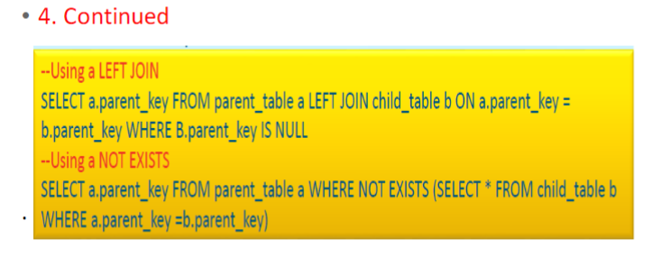 5. Avoid using a scalar user

-defined function in the WHERE clause. Scalar user-defined functions, unlike scalar subqueries, are not optimized into the main query plan. Instead, you must call them row-by-row by using a hidden cursor.

This is especially troublesome in the WHERE clause because the function is called for every input row. Using a scalar function in the SELECT list is much less problematic because the rows have already been

filtered in the WHERE clause

6. Use table-valued user-defined functions as derived tables.

•In contrast to scalar user-defined functions, table-valued functions are often helpful from a performance point of view when you use them as derived tables.

•The query processor evaluates a derived table only once per query.

•If you embed the logic in a table-valued user-defined function, you can encapsulate and reuse it for other queries

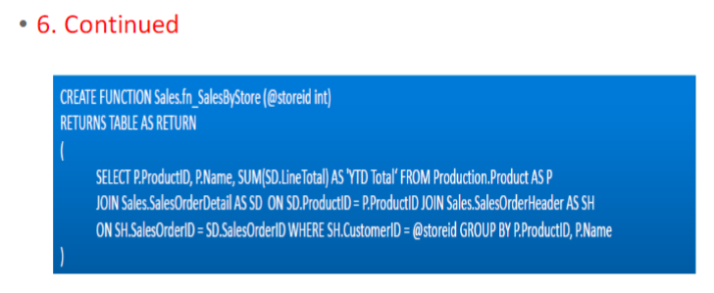

7 Avoid unnecessary GROUP BY columns

Use a subquery instead.

•The process of grouping rows becomes more expensive as you add more columns to the GROUP BY list.

•If your query has few column aggregations but many non- aggregated grouped columns, you might be able to refactor it by using a correlated scalar subquery.

•This will result in less work for grouping in the query and therefore possibly better overall query performance

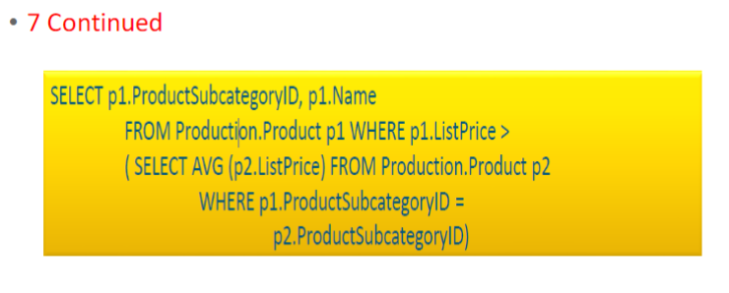

8. Use CASE expressions to include variable logic in a query

The CASE expression is one of the most powerful logic tools available to T-SQL programmers.

•Using CASE, you can dynamically change column output on a row-by-row basis.

•This enables your query to return only the data that is absolutely necessary and therefore reduces the I/O operations and network overhead that is required to assemble and send large result sets to clients

9 Divide joins into temporary tables when you query very large tables.

The query optimizer’s main strategy is to find query plans that satisfy queries by using single operations.

•Although this strategy works for most cases, it can fail for larger sets of data because the huge joins require so much I/O overhead.

•In some cases, a better option is to reduce the working set by using temporary tables to materialize key parts of the query. You can then join the temporary tables to produce a final result.

10. Refactoring Cursors into Queries.

Rebuild logic as multiple queries

•Rebuild logic as a user-defined function

•Rebuild logic as a complex query with a case expression

Stored Procedure

Best Practices

•Avoid using “sp_” as name prefix

•Avoid stored procedures that accept parameters for table names

•Use the SET NOCOUNT ON option in stored procedures

•Limit the use of temporary tables and table variables in stored procedures

•If a stored procedure does multiple data modification operations, make sure to

enlist them in a transaction.

•When working with dynamic T-SQL, use sp_executesql instead of the EXEC

statement

Views

Best Practices

Use views to abstract complex data structures

•Use views to encapsulate aggregate queries

•Use views to provide more user-friendly column names

•Think of reusability when designing views

•Avoid using the ORDER BY clause in views that contain a TOP 100

PERCENT clause.

•Utilize indexes on views that include aggregate data

Recommendations

•Explicitly parameterize variable parts of a query.

•Use stored procedures to implement business functionality.

•Use sp_executesql to avoid stored procedure maintenance.

•Use the prepare/execute model to avoid resending a query string.

•Avoid ad hoc queries.

•Use sp_executesql over EXECUTE for dynamic queries.

•Parameterize variable parts of queries with care.

•Avoid modifying environment settings between connections.

•Avoid the implicit resolution of objects in queries

Transaction Log

A transaction log is a file –integral part of every SQL Server database. It contains a log records produced during the logging process in a SQL Server

database. The transaction log is the most important component of a SQL Server database when it comes to the disaster recovery –however, it must be uncorrupted.

Constraints and Normalization

Primary Key

•PRIMARY KEY constraints identify the column or set of columns that have values that uniquely identify a row in a table

•primary key (PK) of the table and enforces the entity integrity of the table

•A table can have only one PRIMARY KEY constraint, and a column that participates in the PRIMARY KEY constraint cannot accept null values. Because PRIMARY KEY constraints guarantee unique data, they are frequently defined on an identity column.

•If a PRIMARY KEY constraint is defined on more than one column it is called as composite primary key

•If a composite primary key is defined, values may be duplicated within one column, but each combination of values from all the columns in the PRIMARY KEY constraint definition must be unique.

•Composite primary key is a table constraint

Unique

•UNIQUE constraints enforce the uniqueness of the values in a set of columns

•In a UNIQUE constraint, no two rows in the table can have the same value for the columns

•You can use UNIQUE constraints to make sure that no duplicate values are entered in specific columns that

do not participate in a primary key

•Multiple UNIQUE constraints can be defined on a table

•In a UNIQUE constraint, only one null value is allowed per column.

•A UNIQUE constraint can be referenced by a FOREIGN KEY constraint

Composite Key

•A composite key, in the context of relational databases, is a combination of two or more columns in a table that can be used to uniquely identify each row in the table. Uniqueness is only guaranteed when the columns are combined; when taken individually the columns do not guarantee uniqueness.

•This is usually seen in Joint tables.

Candidate Key

•A key that is not a PK but eligible to be a PK.

•Mostly it is a unique key without null value.

Foreign Key

•A foreign key (FK) is a column or combination of columns that is used to establish and enforce a link between the data in two tables. You can create a foreign key by defining a FOREIGN KEY constraint when you create or modify a table.

•In practice, A FOREIGN KEY constraint does not have to be linked only to a PRIMARY KEY constraint in another table; it can also be defined to reference the columns of a UNIQUE constraint in another table, or even any Indexes. In

textbook, it has to be a PK of another table.

•You cannot insert a row with a foreign key value, except NULL, if there is no candidate key with that value.

•The ON DELETE clause controls what actions are taken when you try to delete a row to which existing foreign keys point

NO ACTION specifies that the deletion fails with an error

CASCADE specifies that all the rows with foreign keys pointing to the deleted row are also deleted

SET NULL specifies that all rows with foreign keys pointing to the deleted row are set to NULL

SET DEFAULT specifies that all rows with foreign keys pointing to the deleted row are set to their default value

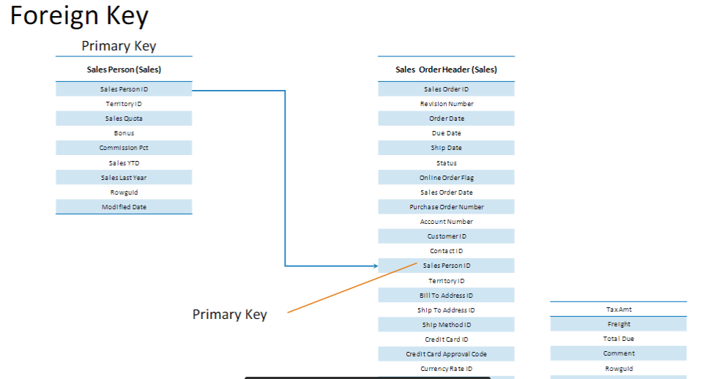

Check Constraints

•CHECK constraints enforce domain integrity by limiting the values that are accepted by a column

•They are similar to FOREIGN KEY constraints in that they control the values that are put in a column. The difference is in how they determine which values are valid: FOREIGN KEY constraints obtain the list of valid values from another table, and CHECK constraints determine the valid values from a logical expression that is not based on data in another column



Integrities of DB

•Domain

•Entity

•Referential

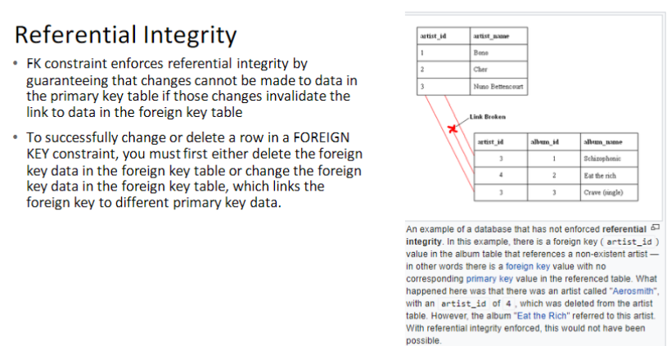

Domain Integrity

•Domain integrity specifies that all columns in a relational database must be declared upon a defined domain. The primary unit of data in the relational data model is the data item. Such data items are said to be non-decomposable or atomic. A domain is a set of values of the same type.

Domains are therefore pools of values from which actual values appearing in the columns of a table are drawn.

Entity Integrity

•Entity integrity concerns the concept of a primary key. Entity integrity is an integrity rule which states that every table must have a primary key and that the column or columns chosen to be the primary key should be unique

and not null.

Normalization in Databases

What is Normalization

•Database Normalization is a process of organizing data to minimize redundancy (data duplication), which in turn ensures data consistency.

•Normalization has a series of steps called “Forms”, the more steps you take the more normalized your tables are.

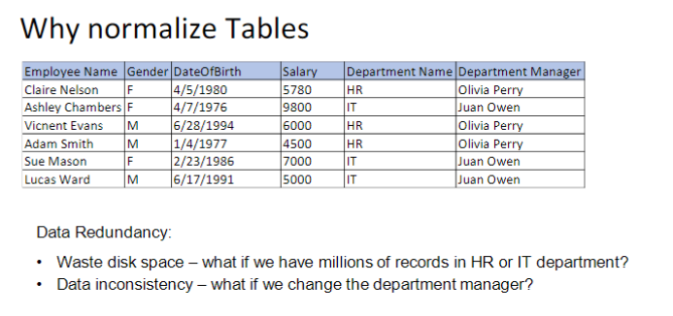

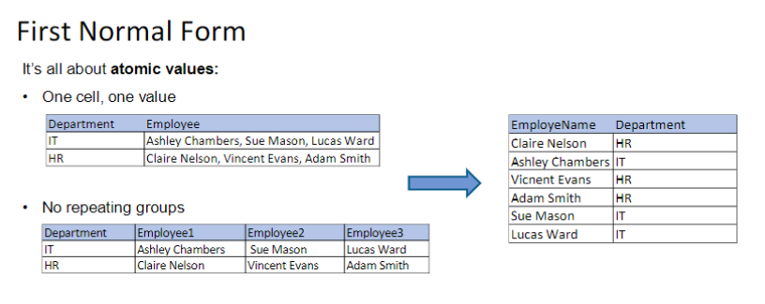 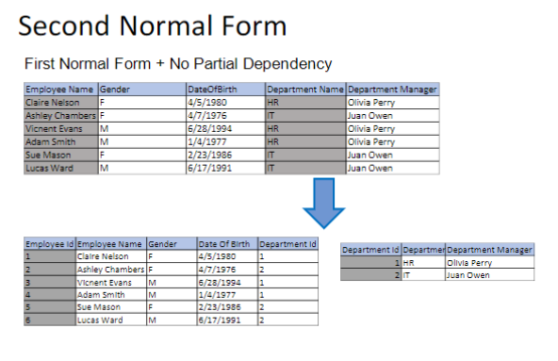

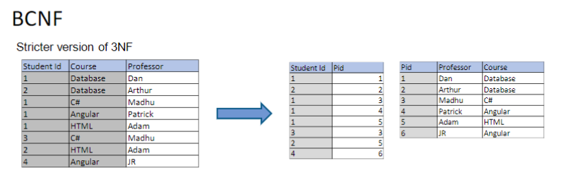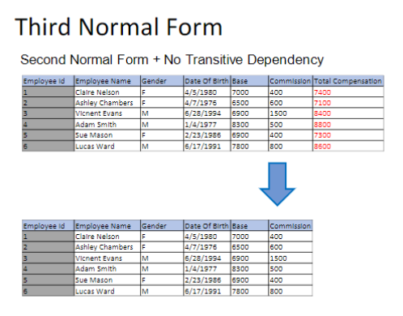

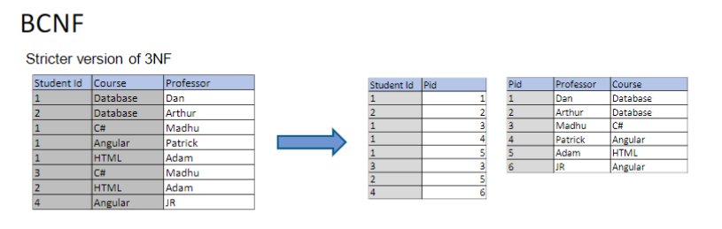

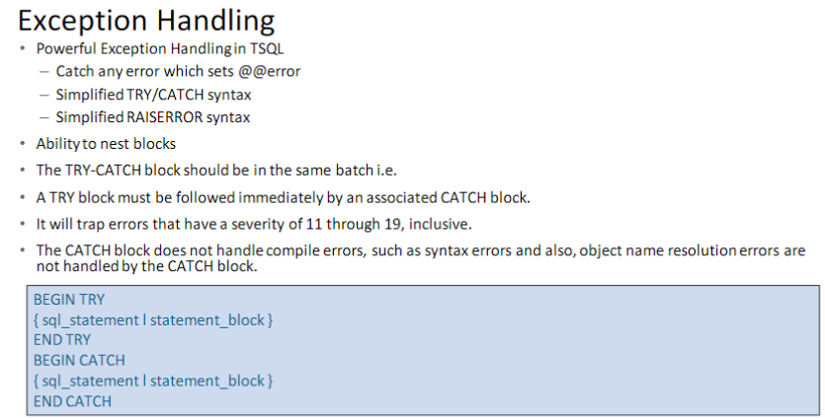 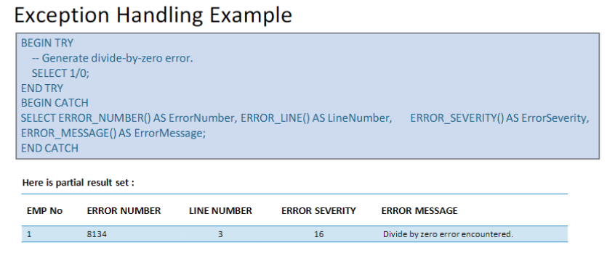

Identity Column

An Identity column is a column (also known as a field) in a database table that is made up of values generated by the database.

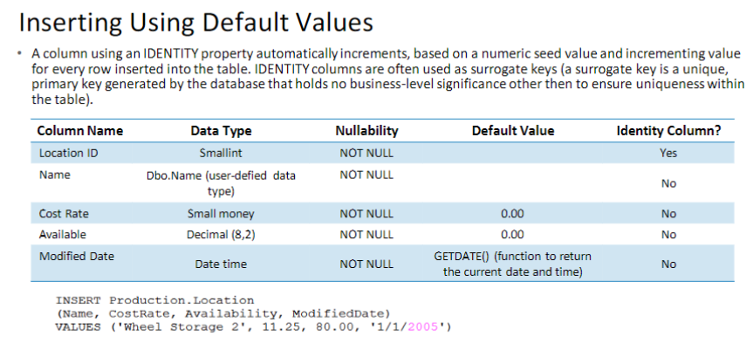

C# day 1

**.Net Introduction**

.NET is a free, open-source development platform for building many kinds of apps, such as Web applications, Web APIs, Microservices, Console, Windows etc. It has following advantages

* Cross Platform
* Open Source
* Numerous programming Language Support
* Built in support for dependency injection
* Middleware support

As mentioned above .Net Supports multliple programing languages, but C# is the most widely used language with .Net.

.Net History

|  |  |  |  |  |
| --- | --- | --- | --- | --- |
| **version** | **date** | **VS version** | **end of support** | **features** |
| **v1.0** | 27- Jun-2016 | VS 2015 – Update 3 | 27-Jun-2019 | Initial release, cross-platform, flexible deployment, open-source, cli-tool, ASP.NET Core, UWP, Xamarin.Forms |
| **v1.1** | 16-Nov-2016 | VS 2017 v15.0 | 27-Jun-2019 | New Linux distros support Improved ASP.NET Core Kestrel server, Azure support, and EF Core support for Azure and SQL 2016 and new APIs addition. |
| **v2.0** | 14-Aug-2017 | VS 2017 v15.3 | 1-Oct-2018 | Implements .NET Standard 2.0, 6 new distros support, RyuJIT is x86 JIT in Core 2.0, dotnet restore now an implicit command. |
| **v2.1** | 30-May-2018 | VS 2017 v15.7 | 21-Aug-2021 | LTS support, Superior performance, and quality, additional distro support such as Ubuntu 18.04, Alpine, ARM32, etc. |
| **v2.2** | 4-Dec-2018 | VS 2019 v16.0 | 23-Dec-2019 | Runtime diagnostics improvements, support for ARM32 for Windows, and Azure Active Directory for SQL client. |
| **v3.0** | 23-sep-2019 | VS 2019 v16.3 | 3-Mar-2020 | Tested on dot.net and bing.com, performance improved greatly, WPF and WinForms support (currently Windows only), support for executable, high-performance APIs, less memory footprint garbage collector, Raspberry Pi, and ARM support added. |
| **v3.1** | 15-Jan-2020 | VS 2019 v16.4 | 3-Dec-2022 | Fixes and refinements were done in .NET Core 3.0 and are given Long Term Support (LTS) for three years. |
| **v.5.0** | 10-Nov-2020 | VS 2019 v16.8 | 3 Months after .NET 6 Release | A new unified platform for Windows, Linux, macOS, iOS, Andriod, tvOS, watchOS, WebAssembly, and more. Single .NET runtime that can be used everywhere having uniform runtime behavior. |

# Common Type System

* The common type system defines how types are declared, used, and managed in the runtime.
* Establishes a framework that enables cross-language integration, type safety, and high performance code
* Provides an object-oriented model that supports the complete implementation of many programming languages
* The common type system supports two types
* 1. Value Types
* 2. Reference Types

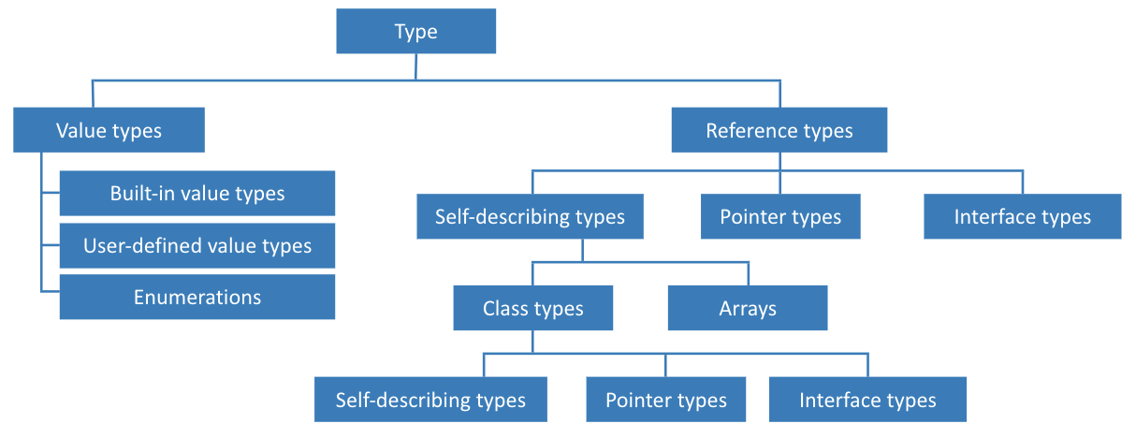

## Difference

|  |  |
| --- | --- |
| Value Types | Reference Types |
| Directly contain their data | Store references to their data (Known as objects) |
| Each has its own copy of data | Two reference variable can reference the same object |
| Operation on one can not effect another | Operation on one can effect another |

### Value Types

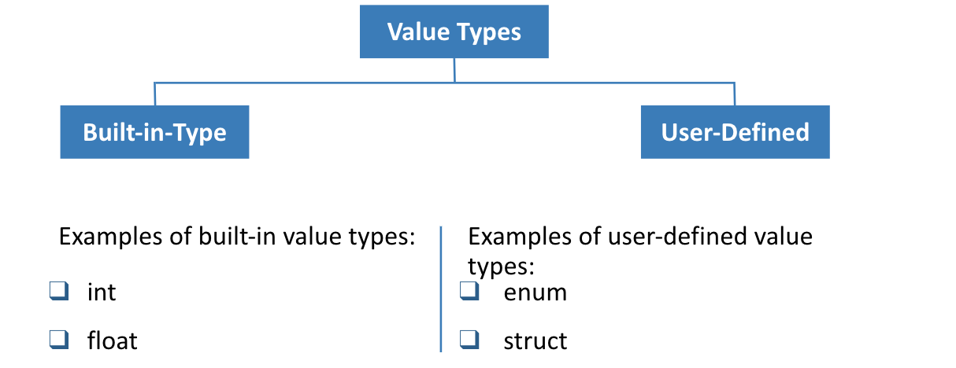

Primitive Data Types

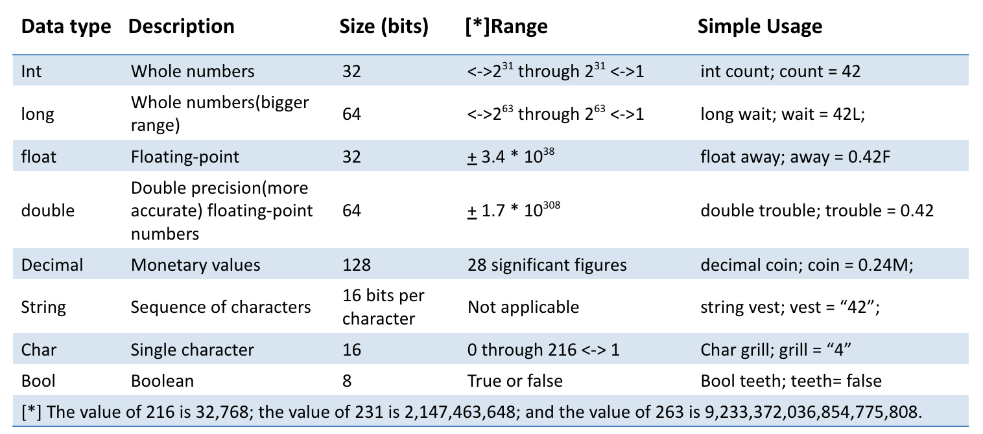

### Identifiers

* Identifiers are the names you use to identify the elements in your programs. In C#, you must adhere to the following syntax rules when choosing identifiers
* You can use only letters (uppercase and lowercase), digits, and underscore characters
* An identifier must start with a letter (an underscore is considered a letter).

examples:  int   productId;

                    int   _Produt;

### Variables

A variable is a storage location that holds a value. You can think of a variable as a box holding temporary

information. You must give each variable in a program a unique name. You use a variable‘s name to refer

 to the value it holds

Declaring Variables

A variable is defined by specifying a type name and a declarator that specifies the variable name and an

optional initial value, as in:

int a;

int b = 1;

Assigning values to variables

Assign values to variables that are already declared:

int itemCount;

itemCount=10;

Initialize a variable when you declare it:

int itemCount=10;

You can also intialize character values:

char middleIntial=‘I’;

### Class Fields

A field is a variable that is associated with a class or struct, or an instance of a class or struct. A field declared with the static modifier defines a static variable, and a field declared without this modifier defines an instance variable. A static field is associated with a type, whereas an instance variable is associated with an instance

             private static DataSet ds;

             public string Name;

             public decimal Salary

### Comments

A  well-commented application permits a developer to fully understand the structure of the application

Single-line comments

// Console.WriteLine(“Test”);

Multiple line comments

/*Console.Write(“Test”);

    Console.Readline()*/

Common Operators

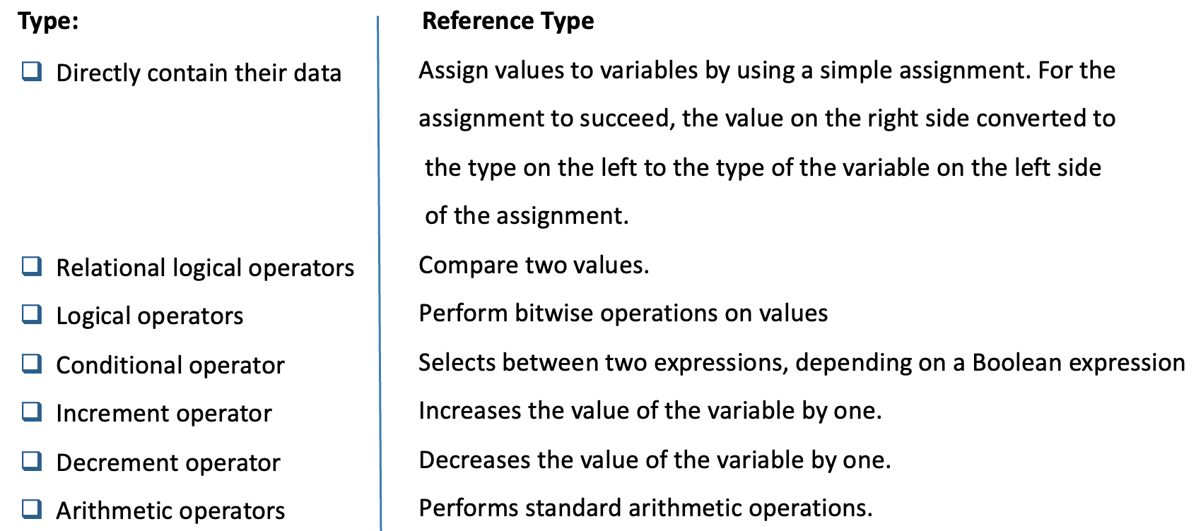

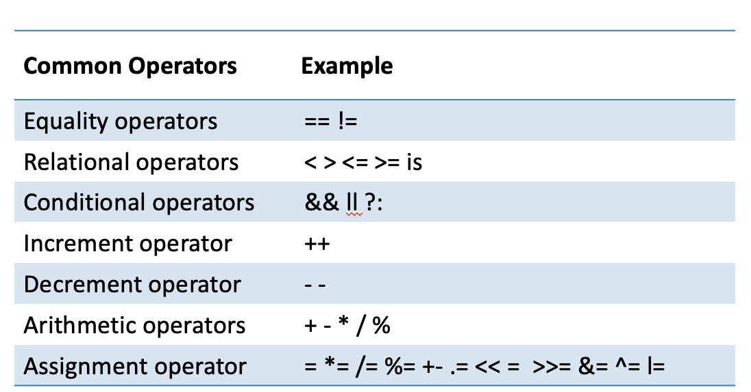

### Operator Precedence

* + When an expression contains multiple operators, the precedence of the operators controls the order in which the individual operators are evaluated.

x + y * z   ----  x+(y*z)

* + When an operand occurs between two operators with the same precedence, the associatively of the operators controls the order in which the operations are performed
  + Except for assignment operators, all binary operators are left-associative
  + Assignment operators and conditional operators are right-associative

### Control Statements

   for selection control statements

      https://docs.microsoft.com/en-us/dotnet/csharp/language-reference/statements/selection-statements#the-if-statement

 for iteration statements

     https://docs.microsoft.com/en-us/dotnet/csharp/language-reference/statements/iteration-statements#the-do-statement

  for jump statements

     https://docs.microsoft.com/en-us/dotnet/csharp/language-reference/statements/jump-statements#the-break-statement

## String vs StringBuilder

* + While working with the String class, every time you perform some operations on your string, you recreate the entire string in the memory over and over again, whereas StringBuilder allocates some buffer space in the memory and applies modifications into that buffer space.
  + As the StringBuilder object is mutable, it provides better performance as compared to the String object when heavy string manipulations are involved.
  + String operations use more memory as compared to StringBuilder because String creates intermediate garbage instances after each operation.
  + String is in System namespace but StringBuilder is in System.Text namespace

## Garbage Collection

  The garbage collector manages the allocation and release of memory for an application. For developers working with managed code, this means that you don't have to write code to perform memory management tasks. Automatic memory management can eliminate common problems, such as forgetting to free an object and causing a memory leak or attempting to access memory for an object that's already been freed.

to find more information use the following link

https://docs.microsoft.com/en-us/dotnet/standard/garbage-collection/fundamentals

# Introduction to C#

C# is an object oriented programming language supported by .Net. It is a case sensitive programing language.

Structure of C# program

            using System;

            class Hello

            {

                   public static void Main()

                   {

                          Console.WriteLine("Hello, World!");

                   }

            }

## Classes in C#

* C# application is a collection of Types , Classes and structures
* A class is a set of  data and methods

Syntax of Class

        public class Class1

            {

            }

* A c#  application consists of many files
* A class cannot span multiple files
* You can put multiple  classes in a single file
* The name of the class and file need not to be same
* Generally the name of the assembly is of  project name

### Main method

While writing Main method, you should:

Use an uppercase “M”, as in “Main”

Designate one Main as the entry point to the program

Declare Main as public static void Main

•       Multiple classes  can have  Main

•       You have to mention which Main you want , while compiling

•       When Main finishes, or returns, the application quits

## Access Modifiers

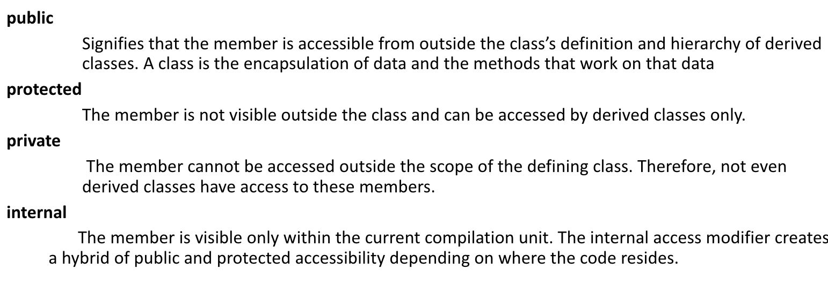

### Methods

* A method is a named sequence of statements
* Method is Functionality member of a Class
* The Syntax of a method is

                  [modifiers] return_type MethodName([parameters]) {    // Method body }

### Name

          You cannot give a method the same name as a variable, a constant, or any other non-method item declared in the class. The method name can be any allowable C# identifier, and it is case sensitive.

### Parameter list

  The method name is followed by a parameter list for the method. This is enclosed between parentheses. The parentheses must be supplied even if there are no parameters, as is shown in the examples on the slide.

### Body of the method

 Following the parentheses is the body of the method. You must enclose the method body within braces ({ and }), even if there is only one statement.

### Calling a method

* Call a method from within the same class

        Use method’s name followed by a parameter list in parentheses

* Call a method that is in a different class

You must indicate to the compiler which class contains the method to call The called method must be declared with the public keyword

* Methods can call methods, which can call other methods, and so on

## Passing Parameters

* By value

Value parameters are sometimes called in parameters because data can be transferred into the method but cannot be transferred out.

* By reference

Reference parameters are sometimes called in/out parameters because data can be transferred into the method and out again.

* By output

Output parameters are sometimes called out parameters because data can be transferred out of the method but cannot be transferred in

* Variable parameter

                Use the params keyword

                Declare as an array at the end of the parameter list

                Always pass by value

* Method Overloading

                    Two or more methods having same name but different signature in the same class is called overloading.

                    By Changing the method Signature – I.e –Changing the parameters by type or Number

**Enum**

* An Enum is a named constant underlying type is any integral type except Char

Enum Syntax: enum color { Red,Green ,Blue};

* Using Enum : color colorPallete = color.Red
* The default underlying type of the enumeration elements is int. By default, the first enumerator has the value 0, and the value of each successive enumerator is increased by 1.

enum Days {Sat=1, Sun, Mon, Tue, Wed, Thu, Fri}; In this enumeration, the sequence of elements is forced to start from 1 instead of 0.

enum Days {Sat=1, Sun, Mon, Tue, Wed, Thu, Fri}; In this enumeration, the sequence of elements is forced to start from 1 instead of 0.

int  x  = (int)DaysSun;Setting base type option as long

enum  range : long{Max=2189900000;min=1000000}

An enum is a user-defined integer type.

                        public enum TimeOfDay

                                    {

                                                    Morning = 0,

                                                    Afternoon = 1,

                                                    Evening = 2

                                    }

                        class EnumExample

                                    {     public static int Main()

                                                {

                                                        WriteGreeting(TimeOfDay.Morning);

                                                        return 0;

                                                }

                                        static void WriteGreeting(TimeOfDay timeOfDay){

                                                       switch(timeOfDay)

                                                            {      case TimeOfDay.Morning:

                                                                       Console.WriteLine("Good morning!");

                                                                           break;

                                                                 case TimeOfDay.Afternoon:

                                                                          Console.WriteLine("Good afternoon!");

                                                                  break;

                                                                  case TimeOfDay.Evening:

                                                                            Console.WriteLine("Good evening!");

                                                                   break;

                                                                  default:

                                                                            Console.WriteLine("Hello!");        break;

                                                                }

                                                    }

                                        }

You can retrieve the string representation of an enum as in the following example, using the earlier

                TimeOfDay enum:

                TimeOfDay time = TimeOfDay.Afternoon;

                Console.WriteLine(time.ToString());

This will return the string Afternoon.

Alternatively, you can obtain an enum value from a string:

                TimeOfDay time2 = (TimeOfDay) Enum.Parse(typeof(TimeOfDay), "afternoon", true);

                Console.WriteLine((int)time2);

What do we need to write C# code

•Microsoft .NET: The platform we need to run C# programs

•C# language: convert C# code to machine code and make it executable

•Visual Studio: The Integrated Development Environment

.NET Core Or .NET Framework

•.NET Core:

•Open Source

•Cross

-platform: windows, Mac OS, Linux, etc.

•Web applications, windows mobile, and windows store

•.NET Framework:

•Windows operating system

•Desktop and web applications

•Does not support microservices

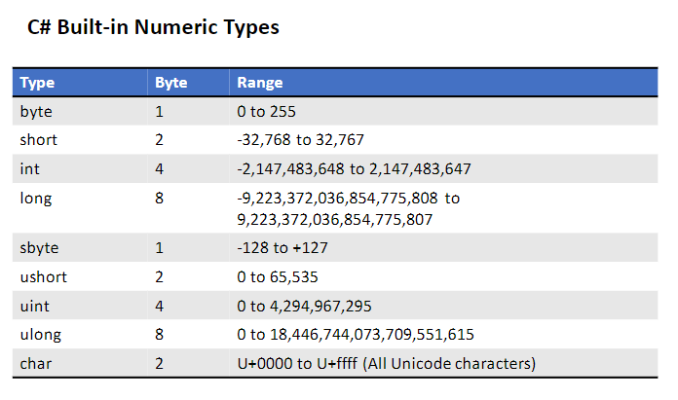

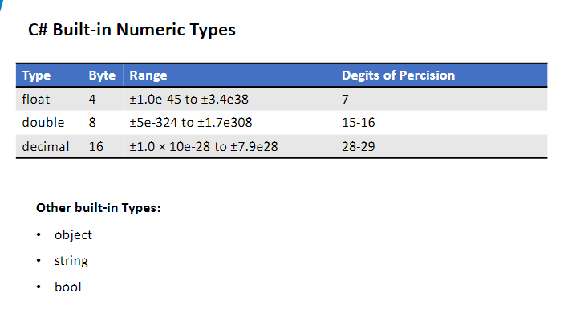

C# User Defined Types

•Class

•Enum

•Interface

•Delegate

•...C# Data Types

•Value Type: directly hold the value

•int, float, double, bool

•Cannot accept null value

•Use Struct or Enum to create

•Not collected by garbage collector

•Stored in stack memory

•Reference Type: hold the memory address for this value

•string, StringBuilder, object

•Use Class, Interface or Array to create

•Collected by garbage collector

•Stored in heap memory

C# Casing Techniques

•Pascal Casing:

First letter of the identifier must be written in uppercase, and remaining must be in lowercase; if an identifier is the combination of two or more words, first letter for all words must be uppercase, and remaining characters must be

lowercase.

Use Pascal casing to name a Class, Method / Function, Namespace, Interface, Delegates, Properties

•Camel Casing:

identifier should be in lowercase, if an identifier is the combination of

two or more words, then first word must be in lowercase, the remaining words follow the Pascal casing.

C# Garbage Collection

•Garbage Collector: automatic memory manager

•Benefits:

•Don’t need to manually release memory

•Allocates objects on managed heap efficiently

•Generations: 0, 1, and 2 to handle long

-lived and short

-lived objects separately.

•Generation 0: youngest generation and contains short

-lived objects

•Generation 1: short

-lived objects and serves as a buffer between short

-lived objects and long

-lived objects.

•Generation 2: long

-lived objects.

C# Basics

•Parameter modifiers:

•default parameter: pass by value

•Ref parameter: pass by reference

•Out parameter: return a value without using return statement

•Params parameter: send multiple arguments as a single parameter

C# day 2

**OOP Paradigms**

* Abstraction Modeling the relevant attributes and interactions of entities as classes to define an abstract representation of a system.
* Encapsulation Hiding the internal state and functionality of an object and only allowing access through a public set of functions.
* Inheritance Ability to create new abstractions based on existing abstractions.
* Polymorphism Ability to implement inherited properties or methods in different ways across multiple abstractions

**Class example**

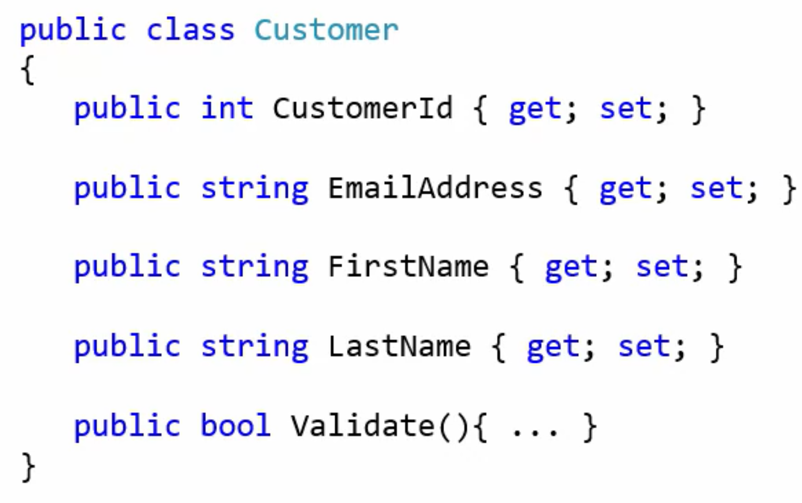

Object of the class

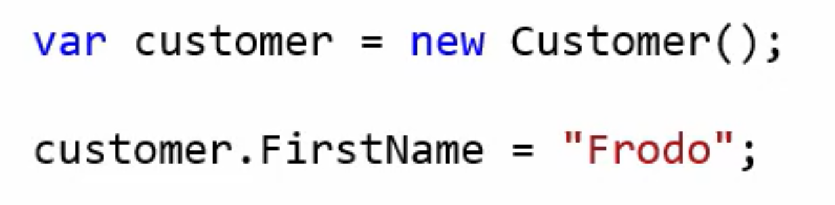

**Constructor**

* A constructor is special member function shares the name of the class
* Constructor is used to create instance of the class
* Constructor can be overloaded with multiple parameters
* If there is no constructor then compiler provides a default constructor
* A default constructor is always replaced by the custom customer
* Constructor is used to initialize the class fields
* Constructor can not have any return type not even void

**Properties**

A property is a member that provides a flexible mechanism to read, write, or compute the value of a private field. Properties can be used as if they are public data members, but they are actually special methods called accessors. This enables data to be accessed easily and still helps promote the safety and flexibility of methods

 Properties have two blocks get and set respectively. Get block is used to return the value of the private variable and set is used to assign value to the private variable.

 read more about properties on the below link

https://docs.microsoft.com/en-us/dotnet/csharp/programming-guide/classes-and-structs/properties

Inheritance

* Derived Class / Child Class - the class that inherits from another class
* Base Class / Parent Class - the class being inherited from
* Single Inheritance: one class can only have one parent class
* Benefits: reuse the code

**Polymorphism: many forms**

1. Method overriding:

            Methods in base class and its subclasses share the same method name and same input parameters

            Keyword: Virtual / Abstract in base class methods; Override in derived class methods

            Runtime polymorphism

1. Method overloading:

            Methods in same class share the same method name, but different input parameters

            Compile time polymorphism

**Abstract Class**

* Abstract Class is always a based class and marked with abstract keyword
* It can not be instantiated
* It can have both abstract and concrete methods
* It can have constructors, fields and public/protected/private members
* One class can inherit only one Abstract class

**Abstract method**

* Abstract method is a method which can not have body.
* It must be implemented in the derived class.
* It is by default virtual so we can not use virtual keyword with an abstract method
* If a method is marked abstract then the class containing it must be marked as abstract

**Sealed Keyword**

* Sealed classes are not inheritable. If you want no one to inherit your class then mark it seal.

C# is an OOP language

•Why Object Oriented Programming:

•Write clean code

•Defend our code against errors

•Build API or .NET Application

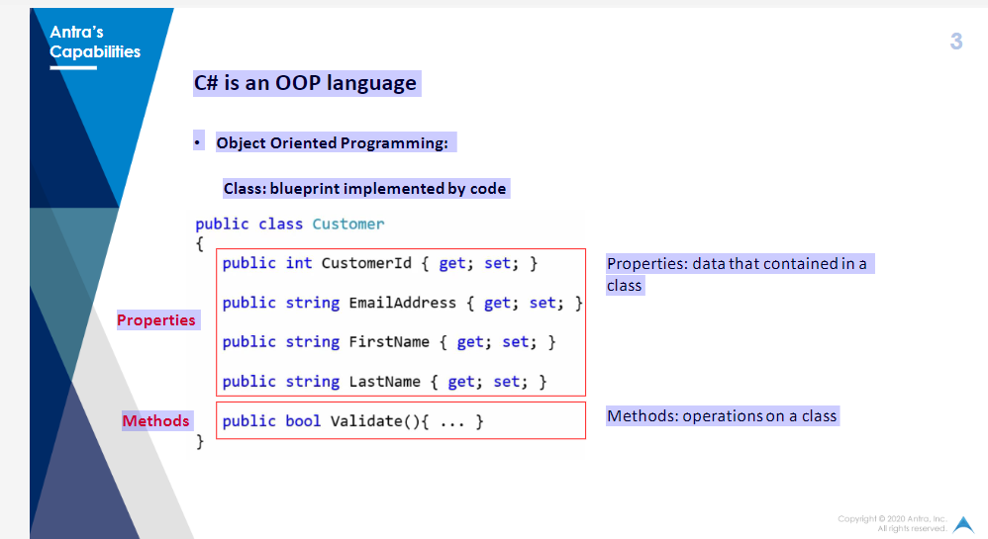

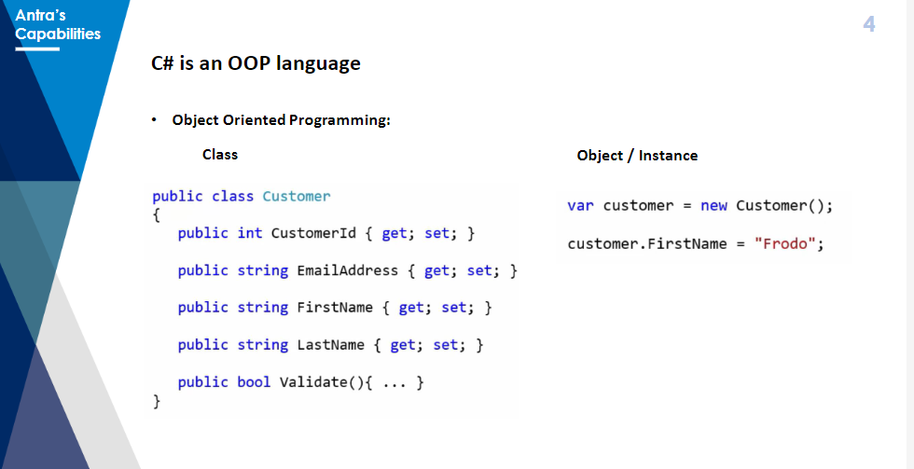

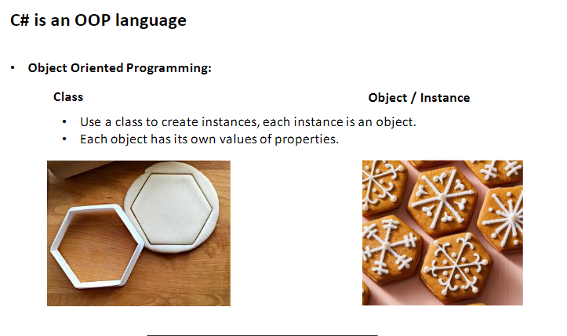

•Constructor: create instance; share the same name with the class

•Parameterless constructor: by default

•Overloaded constructors

•Static constructor: initializes static members of the type; parameterless

•Encapsulation: hide data implementation

•Get & set accessor

•Access Modifiers:

•Public: accessible everywhere

•Protected: accessible in the same class or derived class

•Internal: accessible in the same assembly

•Private: accessible only in current class

•Inheritance

•Derived Class / Child Class

-the class that inherits from another class

•Base Class / Parent Class

-the class being inherited from

•Single Inheritance: one class can only have one parent class

•Benefits: reuse the code

•Polymorphism: many forms

•Method overriding:

•Methods in base class and its subclasses share the same method name and

same input parameters

•Keyword: Virtual / Abstract in base class methods; Override in derived

class methods

•Runtime polymorphism

•Method overloading:

•Methods in same class share the same method name, but different input

parameters

•Compile time polymorphism

•Abstract method

•Only be contained in an abstract class.

•No implementation

•Must be overridden in derived classes

•Virtual Method

•Can be contained in both abstract class and concrete classes

•Has default implementation

•Overriding in derived classes is optional

•Abstract class:

•Contain at least one abstract methods

•Can contain both abstract and concrete methods

•Cannot be instantiated

•Sealed modifier:

•Sealed class: a class cannot be inherited

•Sealed methods: a method cannot be overridden

•Static modifier:

•Static class:

•Cannot be inherited

•Cannot be instantiated

•Only contain static members

•Static methods:

•Belong to the class, not specific objects

•Call by class name

C# day3

# Interface

* Interface defines the a contract which is implemented by the derived classes.
* As of naming convention an interface name must start with capital letter 'I'
* Interface supports multiple inheritance.
* By default all the members inside are public and abstract.
* Interface can not have constructor and fields.
* Interface can have properties but derived class must override them.
* Helps in writing loosly coupled code.

## Interface vs Abstract Class

* Interface supports multiple inheritance but abstract class does not
* Interface cannot have instanced constructor but abstract class can have
* Interface has by default all members abstract and public, but abstract class can have abstract and concrete members
* Interface cannot have fields but abstract class can have fields.

**Extension method**

Extension method is a way to add new functionality into an existing type (both reference and value). LINQ and Dapper are based on Extension methods. We have used extension methods to create custom html helpers in MVC. To create an extension method follow these four steps

* Class containing extension method must be static.
* Extension method must be static
* First parameter to the extension method must be the type to be extended
* First parameter must be written after this keyword

# Generics

Generic allows you to use a class or method that can work with any data type. You need to define the data type while using class or method. Usually the type is specified by the <T>.  You can make a class, interface or method generic.

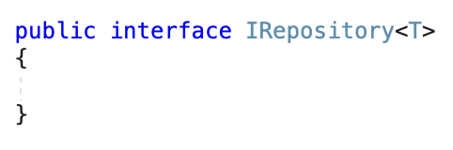

You can also restrict a generic to accept value type or reference type using where

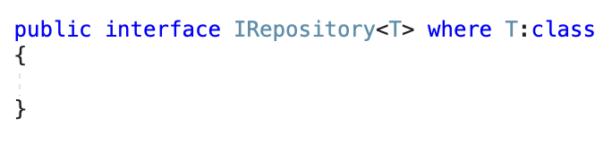

once a type is generic you can use the data type with the methods inside that

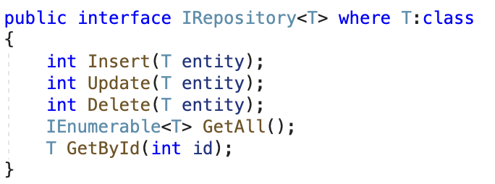

## Generic Collection

They are multiple generic collections in C#. Most widely used are following

* IEnumerable<T>
* IQueryable<T>
* List<T>
* Dictionary<TKey,TValue>

To know more about generics. visit the documentation

https://docs.microsoft.com/en-us/dotnet/csharp/fundamentals/types/generics

Difference between Generics and Non Generic Collection

|  |  |
| --- | --- |
| Generics | Non Generics |
| A Generic collection is a class that provides type safety without having to derive from a base collection type and implement type-specific members. | A Non-generic collection is a specialized class for data storage and retrieval that provides support for stacks, queues, lists and hash tables. |
| The Generic Collection classes are in the System. Collections. Generics namespace. | The Non -generic Collection classes are in the System. Collections namespace. |
| A Generic Collection is strongly typed. | A Non-Generic Collection is not strongly typed. |
| The Generic Collections store elements internally in arrays of their actual types. | The Non-generic collections store elements internally in object arrays so it can store any type of data. |

## C# day4

# Exception Handling

* An error, which is an event that happens during the execution of code, interrupts or disrupts the code's normal flow and creates an exception object
* When an error interrupts the flow, the program tries to find an exception handler — a block of code that tells it how to react — that will help it resume the flow
* Exception handling" means interpreting and reacting to the exceptions created by errors.
* .Net uses structured error handling
* Structured exception handling uses a control structure containing exceptions, isolated blocks of code, and filters to create an exception handling mechanism. This allows your code to differentiate between different types of errors and react in accordance with circumstances

### Structured Exception Handling

* The Try...Catch...Finally control structure is fundamental to structured exception handling
* It tests a piece of code, filters exceptions created by the execution of that code, and reacts differently based on the type of thrown exception.
* The Try statement provides the code that is being tested for exceptions
* Catch clauses identify blocks of code that are associated with specific exceptions series of Catch blocks
* The Finally statement contains code that executes regardless of whether or not an exception occurs within the Try block
* We can have nested try blocks
* Catch Blocks will in order of most specific to most generic

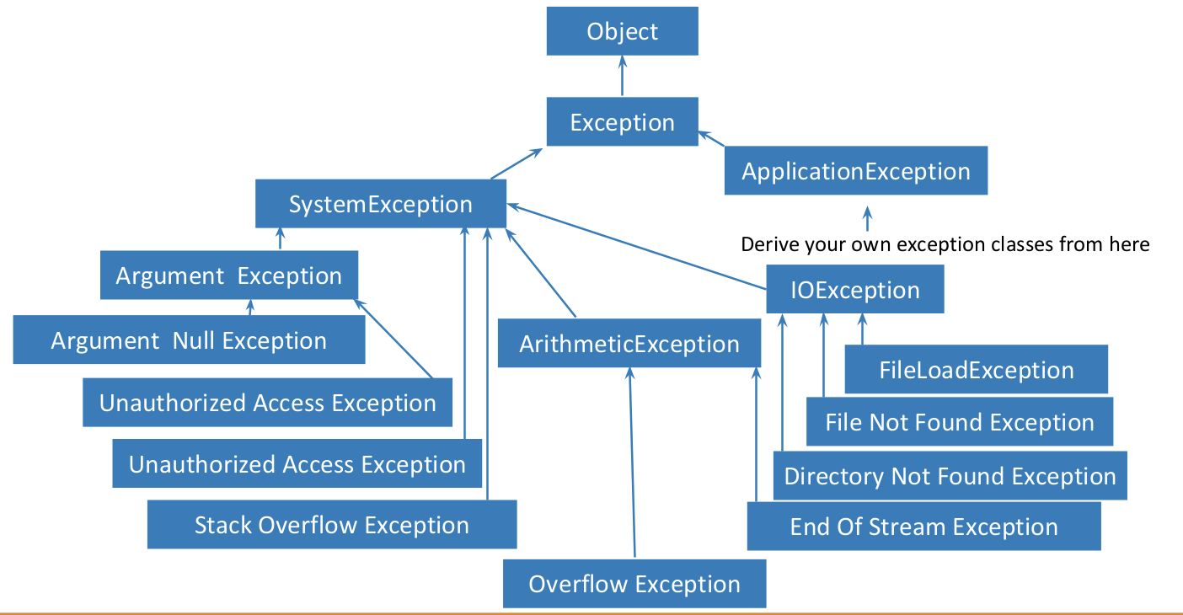

### User Defined Exception

* User defined exceptions must be derived from Application exception
* Avoid exceptions for normal or expected cases
* Never create or throw objects of class Exception
* Include a description string in an Exception object
* Throw objects of the most specific class possible
* It is perfectly legitimate to throw exceptions from catch and finally blocks

# Delegate

* A delegate is a type safe function pointer.
* The signature of delegate must match the signature of function, the delegate points to.



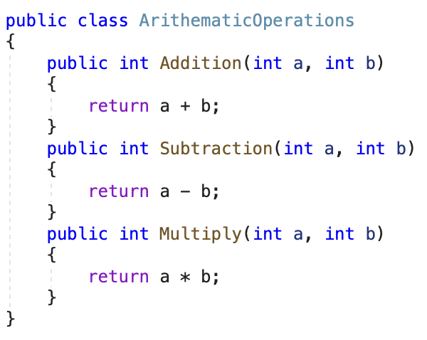

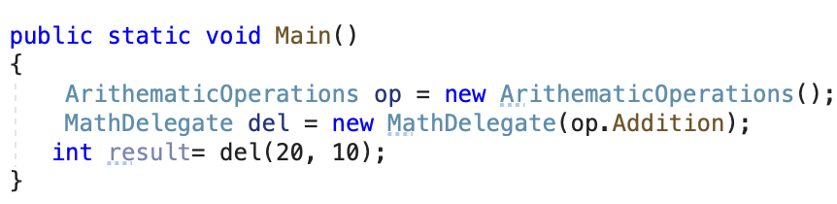

### Anonymous Type

* Encapsulate a set of read-only properties and their value into a single object
* No need to explicitly define a type first.
* Use of the new var keyword in conjunction with the object initialization syntax



* At compile time, the C# compiler will autogenerate an uniquely named class
* The class name is not visible from C#
* Using implicit typing (var keyword) is mandatory
* Anonymous types are reference types directly derived from System.Object

### Anonymous method

Anonymous method is a method without a name. A delegate is used to create an anonymous method.

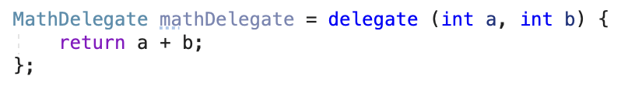

An anonymous method can be created with the help of lambda operator (=>)

### Lambda Operator =>

Lambda operator is used to create an anonymous method. It uses delegate to create an anonymous method. Left side to lambda operator is parameter/s and right side method body



### Action, Predicate and Func

* Action, Predicate and Func are predefined generic delegate.
* Action delegate takes generic input parameter and does not return any value. Its return type is void
* Predicate delegate takes generic input parameter and returns boolean value
* Func delegate takes generic input parameters and returns generic value

C# day 5

## Basic

* LINQ stands for Language Integrated Query
* LINQ (Language Integrated Query) is uniform query syntax in C# to save and retrieve data from different sources.
* One of the central, and most important, features of LINQ is its integration of a flexible query syntax into the C# language.
* Write queries against in-memory collections and other queryable sources using LINQ.
* Write data access code directly against a Microsoft SQL Server database by using LINQ to SQL
* Write data access code for XML data by using LINQ to XML
* Write common data access code across different data providers and storage schemas by using LINQ to Entities
* Write rich queries against data in a Microsoft DataSet by using LINQ to DataSet

## Type Of Linq

* Linq to Objects
* Linq to Dataset
* Linq to Sql
* Linq to Entities
* Linq to XML

## Query Expression

* Projection= Select <expr>, Return <expr>
* Filter= Where <expr>, Distinct
* Test= Any(<expr>), All(<expr>)
* Join= <expr> Join <expr> On <expr> = <expr>
* Group= Group By <expr>, <expr> Aggregate <expr>, <expr>, Group Join <decl> On <expr> = <expr> Aggregate <expr>
* Aggregate= Count(<expr>), Sum(<expr>), Min(<expr>), Max(<expr>), Avg(<expr>), Group(<expr>)…
* Partition= Skip [ While ] <expr>, Take [ While ] <expr>
* Set= Union, Intersect, Except
* Order= Order By <expr>, <expr>

Syntax Type

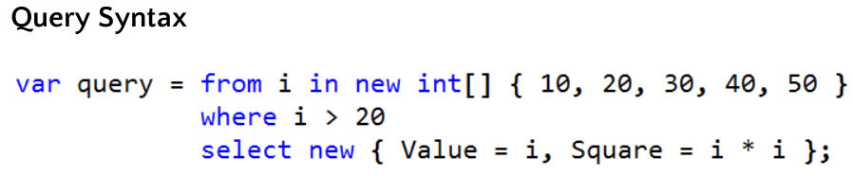

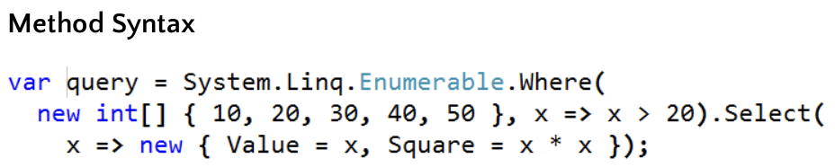

## LINQ queries

* Query is an expression that retrieves data from a data source.
* Queries are usually expressed in a specialized query language
* Different languages have been developed over time for the various types of data sources, for example SQL for relational databases and XQuery for XML.
* LINQ offers a consistent model for working with data across various kinds of data sources and formats.
* All LINQ query operations consist of three distinct actions: Obtain the data source, Create the query, Execute the query.
* Query is executed in a foreach statement, and foreach requires IEnumerable or IEnumerable<T>.

### Deferred Execution

* A query variable only stores the query commands. The actual execution of the query is deferred until you iterate over the query variable in a for each statement.
* This concept is considered as deferred execution.
* Deferred execution can greatly improve performance when you have to manipulate large data collections.
* The collection results will have smaller memory foot prints.

### Forcing Immediate Execution

* Queries that perform aggregation functions over a range of source elements must first iterate over those elements.
* Examples of such queries are Count, Max, Average, and First. These execute without an explicit foreach statement because the query itself must use foreach in order to return a result.
* To force immediate execution of any query and cache its results, you can call the ToList<TSource> or ToArray<TSource> methods.

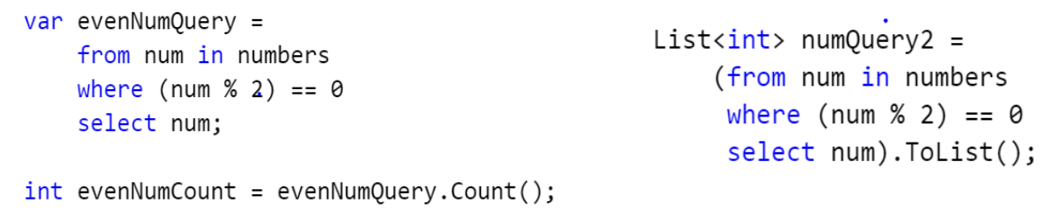

Recap:

1. Generics

2. Delegates: Func, Action, Predicate

3. Extension methods

LINQ: is a sql-like syntax that we can use in C# to get data from different data sources

in-memory data source: data stored temporarily in our application as type of list, array --> IEnumerable

out of memory data source: data existing somewhere outside the application --> IQuerable

LINQ is a bunch of extension methods that provide addtion functionalities on IEnumerable<T>

select a single record:

First vs. FirstOrDefault

Single vs. SingleOrDefault

First: return the first record when there is one or more records found; if not matched --> throw and exception

FirstOrDefault: return the first record when tehre is one or more records found; if not matched --> assign the default value

Single: return the matched single record; if not matched --> throw an exception; if there is more than one match --> throw an exception

SingleOrDefault: return the matched single record; if not matched --> assign the default value; if there is more than one match --> throw an exception

SKIP AND TAKE

All(): check if all the elements satisfy the specific condition, if yes return true, if no return false

Any(): check if any of the elements satisfy the specific condition, if yes return ture, if no return false

Inner Join:

var result = from c in Customers join o in Orders on c.CustomerID

equals o.CustomerID

select new {c.CustomerID, c.ContactName, o.OrderDate};

Left Join:

var result = from c in Customers join o in Orders on c.CustomerID

equals o.CustomerID  **into customerOrders**  //store it into a temporary collection

**from co in customerOrders.DefaultIfEmpty()**

select new {c.CustomerID, c.ContactName,  **co**.OrderDate};